**A MAJOR PROJECT REPORT ON**

**AI BASED SIGN LANGUAGE TRANSLATOR**

Submitted in partial fulfilment of the requirements for the award of the degree

**BACHELOR OF TECHNOLOGY**

in

**COMPUTER SCIENCE & ENGINEERING**

Submitted by

B. Manoja (213H1A0508)

S. Haseena Bhanu (213H1A0550)

S. Gulam Nikhat Sultana (213H1A0555)

D. Likhitha (213H1A0514)

N. Nikhitha (213H1A0535)

**Under the esteemed guidance of**

**Smt. S.Swetha, M.Tech (Ph.D)**

 Assistant Professor, Department of AIML

**DEPARTMENT OF COMPUTER SCIENCE & ENGINEERING**

**K.L.M COLLEGE OF ENGINEERING FOR WOMEN**

(Approved by AICTE and Affiliated to JNTU Anantapuramu)

Kadapa – 516003

**Academic Year: 2024–2025**

##### K.L.M COLLEGE OF ENGINEERING FOR WOMEN

 (APPROVED BY AICTE AND AFFILIATED TO J.N.T.U. ANANTAPURAMU)

DEPARTMENT OF COMPUTER SCIENCE & ENGINEERING

**CERTIFICATE**

This is to certify that the project report entitled “AI BASED SIGN LANGUAGE TRANSLATOR” that is being submitted by

B. Manoja (213H1A0508)

S. Haseena Bhanu (213H1A0550)

S. Gulam Nikhat Sultana (213H1A0555)

D. Likhitha (213H1A0514)

N. Nikhitha (213H1A0535)

In partial fulfilment of the requirements of the award of the Degree of Bachelor of Technology in COMPUTER SCIENCE AND ENGINEERING to the **Jawaharlal Nehru Technological University Anantapur** is a record of bonafide work carried out by under my guidance and supervision. The results embodied in this project report have not been submitted to any other university or institute for the award of any degree.

**Internal Guide Head of the Department**

**Smt.S.Swetha, M.Tech**  **Mr.D. SREENIVASULU,M.Tech (Ph.D)**

Assistant Professor, Department of AIML  **Assistant Professor,** Department of CSE.

Submitted for university Examination (Viva Voice) held on

Internal Examiner External Examiner

## VISION AND MISSION OF COLLEGE

##### VISION

To be an Institution which aims at empowering women through delivering quality Technical Education While Keeping Moral Integrity intact.

##### MISSION

To provide high standard of Technical Education to women students enabling them to face all challenges of their personal and professional life with courage and confidence.

To make women students as global citizens by inculcating critical thinking, effective communication, robust engineering knowledge and ethical behaviour in them.

To provide an environment that has values and encourages knowledge acquisition, gender equality and academic freedom, making this a preferred Institution for knowledge seekers.

To install self confidence among rural students by supplementing with co- curricular and extra-curricular activities.

**Department of Computer Science and Engineering**

Certificate

**This is to certify that the project work entitled**

**HEART ATTACK RISK PREDICTION USING MACHINE LEARNING ALGORITHMS**

**is the bonafide work done by**

P. LALITH KUMAR REDDY 20KH1A0586

S. VIVEK VARDHAN RAJU 20KH1A05A9

**In the Department of Computer Science and Engineering, Sri Venkateswara College of Engineering, Kadapa is affiliated to JNTUA-Anantapur in partial fulfillment of the requirements for the award of Bachelor of Technology in Computer Science and Engineering during 2020-2024.**

**This work has been carried out under my guidance and supervision.**

**The results embodied in this Project report have not been submitted in any University or Organization for the award of any degree or diploma.**

**INTERNAL GUIDE HEAD OF THE DEPARTMENT**

**Mr. G. SREENIVASULU, M. Tech.,(Ph.D) Mr. G. SREENIVASULU, M. Tech.,(Ph.D)**

**Assistant Professor & HoD Assistant Professor & HoD**

**INTERNAL EXAMINER EXTERNAL EXAMINER**

We are extremely thankful to our beloved chairman and establisher **Sri A. Gangi Reddy** for providing necessary infrastructure and resources for the accomplishment of our project at **Sri Venkateswara College of Engineering, Kadapa.**

We are highly indebted to **Dr. R. Veera Sudarsana Reddy, Principal** of **Sri Venkateswara College of Engineering, Kadapa**, for his support during the tenure of the project.

We are very much obliged to our beloved **Mr. G. Sreenivasulu, Head of the Department of Computer Science & Engineering**, Sri Venkateswara College of Engineering for providing the opportunity to undertake this project and encouragement in completion of this project.

We here by wish to express deep sense of gratitude to **Mr. G. Sreenivasulu**, Department of Computer Science and Engineering, Sri Venkateswara College of Engineering for the esteemed guidance, moral support and invaluable advice provided by him for the success of the project.

We are also thankful to all the staff members of Computer Science and Engineering department who have co-operated in making our project a success. We would like to thank all our parents and friends who extended their help, encouragement and moral support either directly or indirectly in our project work.

Thanks for Your Valuable Guidance and kind support.

We hereby declare that project report entitled **INTELLIGENT FACE DETECTION WITH AI AND ML INTEGRATION** is a genuine project work carried out by us, in B. Tech (Computer Science and Engineering) degree course of **JAWAHARLAL NEHRU TECHNOLOGICAL UNIVERSITY ANANTAPUR** and has not been

submitted to any other courses or University for award of any degree by us.

**Signature of the Student**

1. P. LALITH KUMAR REDDY
2. U. THARUN REDDY
3. T. NAGENDRA
4. P. MAHESH BABU
5. S. VIVEK VARDHAN RAJU

ABSTRACT

Communication is a fundamental part of human interaction, but people with hearing and speech impairments often struggle to communicate effectively with those unfamiliar with sign language. To address this issue, the project introduces an AI-Based Sign Language Translator that uses computer vision and machine learning techniques to convert hand gestures into text in real time. The system captures hand signs using a webcam and applies the K-Nearest Neighbors (KNN) algorithm to recognize and classify the gestures based on extracted hand landmarks.

The model is trained on a custom dataset created through webcam input, where each gesture is saved and labeled using a structured pipeline. MediaPipe is used to extract 21-point hand landmarks, and OpenCV handles image processing and display. The model is trained using scikit-learn, and the trained classifier is saved for real-time use. The system is modular, consisting of dataset generation, training, recognition, and utility components, allowing ease of maintenance and scalability. Unlike traditional glove-based or sensor-dependent systems, this solution is software-based, making it more affordable, user-friendly, and practical for real-world application.

In the future, the system can be enhanced to recognize dynamic gestures, complete words, and full sentences. Additional features like voice output and deployment on mobile or edge devices (like Raspberry Pi) can increase portability. Also, expanding the model to support multiple sign languages, including regional and international variants, will improve its inclusivity and usability for a global audience. This project demonstrates how AI can create inclusive technologies to reduce communication barriers and promote social integration.

|  |  |  |
| --- | --- | --- |
| **Figure No.** | **Description** | **Page No.** |
| 3.1 | Flow Chart for Proposed System | 08 |
| 3.2 | Architecture | 09 |
| 5.1 | Use Case Diagram for System & User | 14 |
| 5.2 | Class Diagram | 14 |
| 5.3 | Sequence Diagram for User & System | 15 |
| 5.4 | Collaboration Diagram | 16 |
| 5.5 | Deployment Diagram | 16 |
| 5.6 | Activity Diagram | 17 |
| 5.7 | Component Diagram | 17 |
| 5.8 | ER Diagram | 18 |
| 5.9 | Data Flow Diagrams | 19 |

|  |  |  |
| --- | --- | --- |
| **Figure No.** | **Description** | **Page No.** |
| 6.1 | PyCharm Welcome Page | 27 |
| 6.2 | Installing Numpy Library | 27 |
| 9.1 | Running Python File | 59 |
| 9.2 | Home Page | 59 |
| 9.3 | After Login Page | 60 |
| 9.4 | Training Page | 60 |
| 9.5 | Record Attendance Page | 61 |
| 9.6 | Attendance Report Page | 61 |
| 9.7 | Recording the attendance through Webcam Page | 62 |
|  |  |  |
|  |  |  |
|  |  |  |

ABSTRACT

LIST OF FIGURES

LIST OF PHOTOGRAPHS

iii iv v

**Chapter No Description Page No**

1. INTRODUCTNo table of figures entries found.ION 1
2. LITERATURE SURVEY 3
3. SYSTEM ANALYSIS 6
   1. Existing System 6
   2. Proposed System 6
   3. Feasibility Study 7
   4. Flow Chart for Proposed System 8
   5. Architecture 9
4. SOFTWARE AND HARDWARE REQUIREMENTS 10
5. SYSTEM DESIGN 11
   1. Input Design 11
   2. Output Design 12
   3. UML Diagrams 12
   4. Use Case Diagram 13
   5. Class Diagram 14
   6. Sequence Diagram 15
   7. Collaboration Diagram 15
   8. Deployment Diagram 16
   9. Activity Diagram 16
   10. Component Diagram 17
   11. ER Diagram 18
   12. DFD Diagram 18
6. MODULE IMPLEMENTATION 21
   1. User 21
   2. System 21
   3. Algorithm 23

## SOURCE CODE 47

## SYSTEM TESTING 56

* 1. Types of Tests 56
  2. Unit Testing 58
  3. Integration Testing 58
  4. Acceptance Testing 58

## OUTPUT SCREENSHOTS 59

## FUTURE ENHANCEMENT 64

## CONCLUSION 65

## BIBLIOGRAPHY 66

# INTRODUCTION

Communication is a basic human need, essential for sharing thoughts, emotions, and information. For individuals with hearing and speech disabilities, sign language acts as a vital communication tool. However, sign language is not universally understood by the general public, which creates a communication barrier between the hearing-impaired and non-signers. This lack of mutual understanding often results in social isolation, miscommunication, and reduced access to essential services for the deaf and mute communities. To address this significant societal challenge, the integration of Artificial Intelligence (AI) with sign language recognition has emerged as a powerful solution.

Traditional approaches to sign language interpretation rely heavily on wearable devices, such as gloves embedded with sensors or EMG-based hardware. While effective to some extent, these systems are often costly, bulky, and uncomfortable to use over extended periods. Additionally, they require frequent calibration and are less adaptable to natural human motion. These drawbacks limit their practicality in real-world, everyday use. Therefore, a software-based alternative using computer vision and machine learning is a promising direction for developing low-cost, accurate, and user-friendly sign language recognition systems.

The proposed system utilizes a webcam to capture hand gestures in real time and employs image processing techniques to detect and extract hand features. Using MediaPipe, the hand's 21 landmark points are identified and used to form a unique vector representation of each gesture. These vectors are then fed into a machine learning algorithm—specifically, the K-Nearest Neighbors (KNN) classifier—to train and predict signs. The trained model is capable of recognizing alphabets or predefined gestures like "hi" or "thank you" and converting them into readable text. This solution is efficient, non-intrusive, and scalable.

The system architecture is modular, consisting of various independent components: dataset generation, model training, real-time recognition, and utility functions for preprocessing. This modularity ensures the system is easy to maintain and expand. The use of open-source libraries like OpenCV, MediaPipe, and scikit-learn ensures accessibility and flexibility for developers. Furthermore, the real-time translator can be used in educational, medical, and public service domains to enable inclusive interactions. With future enhancements such as dynamic gesture recognition, voice output, and mobile deployment, this system has the potential to become a vital communication bridge for millions of people globally.

# LITERATURE SURVEY

Over the years, researchers and developers have explored numerous methods for translating sign language into spoken or written language using a variety of technological approaches. Early systems primarily focused on sensor-based hardware such as gloves, accelerometers, and gyroscopes to track hand movements and finger positions. These wearable systems, like the DataGlove or EMG sensor-based devices, were able to capture high-precision motion data. However, they suffered from several limitations including high cost, discomfort, hardware dependency, limited flexibility, and the requirement of continuous maintenance and calibration. As a result, such systems were not ideal for widespread real-world deployment, especially in low-resource settings.

With the rise of computer vision, researchers shifted their focus to camera-based systems that utilize image and video processing for gesture recognition. These systems eliminate the need for specialized hardware and instead use webcams or mobile cameras to capture hand gestures. One notable advancement was the use of contour detection and skin color segmentation techniques to identify hand regions. While these methods reduced hardware dependency, they were often sensitive to lighting conditions, skin tone variation, and background clutter, which affected accuracy and reliability.

To overcome these challenges, machine learning and deep learning algorithms were integrated with computer vision systems to improve gesture recognition. Traditional algorithms like Support Vector Machines (SVM), Decision Trees, and K-Nearest Neighbors (KNN) provided reliable classification when paired with handcrafted features such as Hu moments, shape descriptors, and edge detection outputs. These models required feature engineering, which made the development process complex and dataset-dependent. Despite that, they performed reasonably well for recognizing static gestures and individual hand signs, making them suitable for alphabet and number recognition.

The advent of deep learning further revolutionized sign language recognition. Convolutional Neural Networks (CNNs) enabled automatic feature extraction from images and proved highly effective for classifying complex gestures. CNNs were later used in projects like American Sign Language (ASL) recognition datasets, where thousands of labeled images were used to train models capable of identifying gestures with high accuracy. Some advanced systems used Recurrent Neural Networks (RNNs) or Long Short-Term Memory (LSTM) networks to capture dynamic signs and sequence-based gestures such as full words or sentences. However, deep learning models require large amounts of data and computational power, which can be a limiting factor in small or resource-constrained projects.

Recently, the integration of real-time hand tracking libraries like Google’s MediaPipe has greatly simplified gesture recognition systems. MediaPipe provides highly efficient detection of 21 hand landmarks from video frames, which serve as reliable input features for classification algorithms. These developments have made it possible to build sign language translators that are lightweight, accurate, and usable on standard webcams and consumer devices. Combining MediaPipe with machine learning algorithms like KNN has become a popular approach in academic and prototype-level projects due to its simplicity and effectiveness.

Several academic studies have demonstrated successful implementation of such systems. For instance, a system using OpenCV, MediaPipe, and KNN achieved promising results for static alphabet recognition with minimal computational overhead. Other projects explored dataset generation techniques that allowed users to create personalized sign databases, increasing model adaptability. Most of these works conclude that while static sign recognition has reached a practical stage, dynamic and context-aware sign language translation remains an ongoing challenge.

In summary, literature shows a clear evolution from hardware-based gesture recognition to vision-based AI-powered systems. While sensor-based systems offer high accuracy, their cost and complexity limit their scalability. On the other hand, vision-based models offer cost-effective and flexible alternatives. The use of MediaPipe for landmark detection and KNN for classification presents a balanced solution for achieving reliable real-time recognition. The proposed system builds upon these insights to provide a practical, user-friendly sign language translator aimed at breaking communication barriers for the hearing and speech impaired

# SYSTEM ANALYSIS

## Existing System:

The existing systems for sign language translation primarily rely on sensor-based technologies such as data gloves, accelerometers, gyroscopes, and electromyography (EMG) sensors. These wearable devices are embedded with sensors that capture hand and finger movements with high precision. Some systems also integrate motion tracking to detect wrist and arm movement. While these methods are capable of producing accurate gesture recognition, they require the user to wear hardware constantly, making them uncomfortable and inconvenient for long-term use. Moreover, these devices need continuous calibration and maintenance, which adds to the complexity of the system. Sensor-based systems are also cost-prohibitive and not accessible for large-scale adoption, especially in underdeveloped regions.

Another limitation of existing systems is their lack of flexibility and generalization. Most hardware-dependent solutions are designed to recognize a limited set of static gestures and struggle with dynamic or real-time interpretations. Their performance can degrade significantly in uncontrolled environments, such as varying lighting conditions or diverse user hand shapes and sizes. Additionally, these systems are not suitable for quick deployment and often require technical expertise to operate. Overall, while existing systems demonstrate the potential of gesture-based communication, they fail to offer an affordable, user-friendly, and scalable solution for real-world applications, highlighting the need for a software-based, camera-driven alternative.

## Proposed System:

The proposed system introduces a cost-effective, real-time sign language translator using computer vision and machine learning. Instead of relying on expensive hardware or wearable sensors, this solution uses a regular webcam to capture hand gestures. MediaPipe is utilized to extract 21-point hand landmarks from the video feed, which are then processed and converted into numerical feature vectors. These vectors serve as input to a K-Nearest Neighbors (KNN) classifier, trained to recognize a variety of sign gestures including alphabets and common phrases. The recognized gesture is instantly displayed as text on the screen, enabling seamless communication for users with hearing or speech impairments.

This system offers significant advantages over traditional methods by being more comfortable, flexible, and accessible. It supports real-time translation without the need for any physical device on the user's hand. Additionally, it is modular in design, comprising dataset generation, training, and recognition modules, which makes it easy to update or expand. The use of open-source tools like OpenCV, MediaPipe, and scikit-learn allows for easy integration and portability. Furthermore, the system can be deployed on various platforms, including desktops and potentially mobile devices, making it a scalable and practical solution for everyday use in schools, public places, and homes. The proposed system introduces a cost-effective, real-time sign language translator using computer vision and machine learning. Instead of relying on expensive hardware or wearable sensors, this solution uses a regular webcam to capture hand gestures. MediaPipe is utilized to extract 21-point hand landmarks from the video feed, which are then processed and converted into numerical feature vectors. These vectors serve as input to a K-Nearest Neighbors (KNN) classifier, trained to recognize a variety of sign gestures including alphabets and common phrases. The recognized gesture is instantly displayed as text on the screen, enabling seamless communication for users with hearing or speech impairments.

This system offers significant advantages over traditional methods by being more comfortable, flexible, and accessible. It supports real-time translation without the need for any physical device on the user's hand. Additionally, it is modular in design, comprising dataset generation, training, and recognition modules, which makes it easy to update or expand. The use of open-source tools like OpenCV, MediaPipe, and scikit-learn allows for easy integration and portability. Furthermore, the system can be deployed on various platforms, including desktops and potentially mobile devices, making it a scalable and practical solution for everyday use in schools, public places, and homes.

## Feasibility Study:

The feasibility of the proposed AI-Based Sign Language Translator has been evaluated across technical, economic, and social dimensions. Technically, the system is highly feasible due to the use of accessible technologies like OpenCV, MediaPipe, and scikit-learn, which are well-supported and compatible with standard computing environments. Economically, the project is cost-effective since it eliminates the need for expensive hardware by utilizing a standard webcam and open-source software, reducing the overall implementation cost. Socially, the system addresses a critical communication gap faced by individuals with hearing and speech impairments, promoting inclusivity and accessibility in education, healthcare, and public services. The modular structure and scalability further enhance its feasibility for real-world deployment and future enhancements

**Economic Feasibility:**

The proposed system is economically feasible as it eliminates the need for costly hardware components such as sensor gloves, EMG devices, or specialized motion-tracking equipment. By relying solely on a standard webcam and open-source software libraries like OpenCV and MediaPipe, the development and deployment costs are significantly reduced. Additionally, the system requires minimal maintenance and does not involve recurring expenses, making it ideal for educational institutions, NGOs, or public facilities with limited budgets. Since the tools and libraries used are freely available, there are no licensing fees, further enhancing the cost-effectiveness of the project and ensuring its affordability for wide-scale implementation

**Technical Feasibility:**

The proposed system is technically feasible as it is built using widely supported and reliable technologies such as Python, OpenCV, MediaPipe, and scikit-learn. These tools are compatible with most operating systems and can run efficiently on standard computing hardware without the need for specialized devices. The use of MediaPipe for hand landmark detection ensures accurate and fast gesture tracking, even in real-time scenarios. The K-Nearest Neighbors (KNN) algorithm, known for its simplicity and effectiveness, provides a lightweight classification model suitable for deployment on desktops and potentially on mobile platforms. The modular architecture further enhances technical viability by allowing easy updates, maintenance, and scalability.

**Social Feasibility:**

The proposed AI-Based Sign Language Translator holds strong social feasibility as it addresses a critical need for inclusive communication between hearing-impaired individuals and the broader community. By enabling real-time gesture recognition and translation without the need for expensive hardware, the system promotes accessibility and equality in education, healthcare, and public interactions. It empowers individuals with speech and hearing impairments to express themselves more freely and be understood by non-signers, thus reducing social isolation. The user-friendly interface and affordable implementation make it practical for widespread adoption in schools, homes, government institutions, and social service organizations.

## Flow Chart for Proposed System

**Fig 3.1: Flow Chart for Proposed System**

## Architecture:

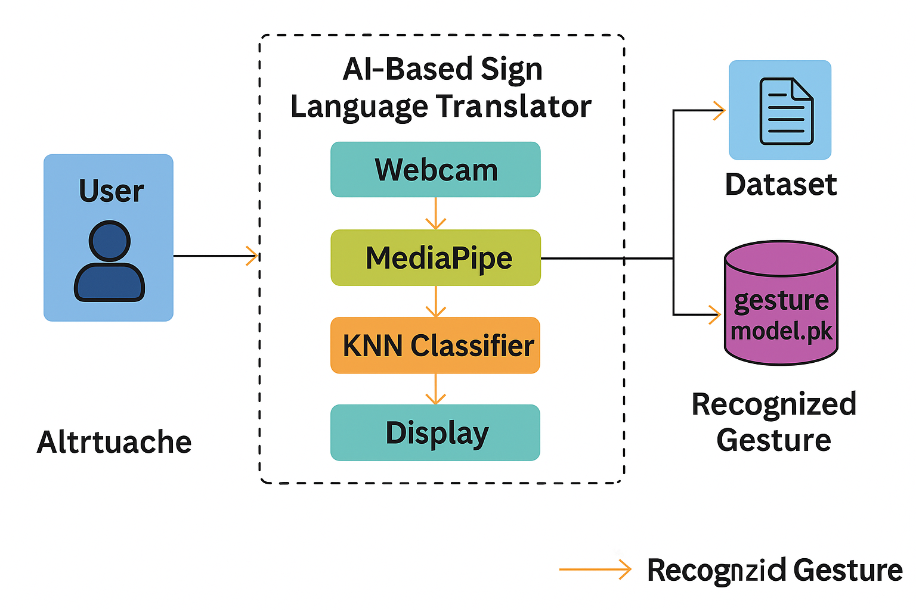

## Fig 3.2: Architecture

**CHAPTER 4: SOFTWARE AND HARDWARE REQUIREMENTS**

# SOFTWARE AND HARDWARE REQUIREMENTS

* 1. **Software Specifications:**
* Operating System: Windows 10 / Linux / macOS
* (The application is platform-independent and works on major OS with Python support)
* Programming Language: Python 3.8 or above
* (Used for implementing all modules including preprocessing, training, and real-time recognition)
* Libraries & Frameworks:
* OpenCV: For capturing webcam input and image processing
* MediaPipe: For real-time hand landmark detection
* scikit-learn: For training the K-Nearest Neighbors (KNN) classifier
* joblib / pickle: For saving and loading trained models
* NumPy: For numerical operations and array handling
* Matplotlib (optional): For visualizing training accuracy or confusion matrix
* os / shutil / glob: For file and directory operations in dataset management
* • IDE / Code Editor:
* VS Code / PyCharm / Jupyter Notebook (for development and debugging)
* Browser:
* Chrome / Firefox (if deploying a web interface using Flask)
* Version Control System:
* Git (for project tracking and collaborative development)
* Execution Environment:
* Local Machine (CPU-based) or Google Colab (GPU optional for model nhancements)
  1. **Hardware Specifications:**

To ensure efficient execution of the RAG Bot system and support for processing large documents and AI model inference, the following hardware configuration is recommended:

**Minimum Requirements**

* **Processor**: Intel Core i5 (8th Gen or higher) / AMD Ryzen 5
* **RAM**: 8 GB
* **Storage**: 256 GB SSD (for faster read/write operations)
* **Graphics**: Integrated GPU or optional basic NVIDIA GPU (not mandatory)
* **Display**: 1366x768 resolution monitor or higher
* **Ports**: USB (for external storage) and stable power source
* **Operating System Support**: Compatible with Windows, Linux, or macOS

**Recommended Requirements**

* **Processor**: Intel Core i7 / AMD Ryzen 7 or higher
* **RAM**: 16 GB (for improved performance with large documents or simultaneous users)
* **Storage**: 512 GB SSD or more
* **GPU**: NVIDIA GPU (with CUDA support) for accelerated AI processing (e.g., RTX 2060 or above)
* **Network**: Required only for initial setup or optional updates; offline operation supported after deployment.

# SYSTEM DESIGN

**INPUT AND OUTPUT DESIGN**

## Input Design:

* Input design is one of the most critical phases of any system, as it defines how information is entered and processed. In the AI-Based Sign Language Translator system, input is primarily captured through a live webcam feed. The webcam acts as a continuous video input source, recording hand gestures performed by the user in front of the camera. This video is processed frame by frame, and each frame is treated as a static image from which the system extracts information. For training purposes, input is taken as individual static hand gesture images saved in a well-structured dataset directory. Each gesture is labeled appropriately (e.g., A, B, C, or words like "hi", "thankyou"), which helps in supervised learning.
* The input must be clean, focused, and well-lit to ensure accuracy in hand landmark detection. For this, users are recommended to use a plain background to minimize noise in gesture recognition. To facilitate dataset generation, the system includes a script (generate_dataset.py) that overlays the expected label and count directly on the screen. The user manually captures images using the 's' key, making the dataset collection process interactive. The extracted features from these input images—specifically, the 21 landmark points on the hand—are then transformed into numerical vectors used for classification. These inputs are fed into the KNN classifier during training and used again during real-time prediction.
* The user input during the real-time translation phase is again a live hand gesture. The recognize_gesture.py script continuously reads webcam input, detects a hand, extracts features, and predicts the gesture. It is essential that the hand be within the frame and positioned clearly. The system uses MediaPipe to detect hand keypoints with high precision and extract relevant coordinates (x, y positions) of each point on the hand. These inputs are then compared against the trained model to classify the gesture. Since the system does not rely on any wearable sensors or physical devices, input is entirely software-handled and requires only a webcam, making the system both accessible and scalable.

To enhance the input experience, the interface may include a bounding box or hand-detection overlay that guides the user on where to place their hand. This improves input quality and helps the algorithm detect consistent hand positions. Furthermore, future enhancements can incorporate dynamic gesture input (e.g., moving signs or word-level signs), which would involve capturing sequences of frames rather than single-frame inputs. This will increase the complexity of the input design but also elevate the system’s performance in real-world use..

* 1. **Output Design:**

The output design focuses on how the recognized gestures are presented to the user in a meaningful, clear, and understandable way. The primary output of the AI-Based Sign Language Translator is textual representation of the detected sign. Once a gesture is successfully recognized through the KNN classifier, the system overlays the corresponding text on the live video stream in real-time. This real-time display allows users to instantly verify the accuracy of the system and make necessary adjustments if the sign is misinterpreted. The output is shown on the same window as the webcam stream, ensuring a seamless and interactive experience.

The system uses OpenCV’s putText() function to render the recognized gesture on the video feed. This output is refreshed frame by frame, allowing for a live translation experience. The font style, size, and color are chosen for maximum visibility and clarity. For instance, a bright green text on a dark video background ensures easy readability. Moreover, the output is updated only when a confident prediction is made, preventing flickering or constant changes during uncertain detection frames.

In the context of system feedback, the output design also incorporates visual cues to inform the user when no hand is detected or when the hand is not in a recognizable position. This helps users adjust their gestures appropriately. Additionally, the output may include a prediction confidence level or label suggestions, especially useful during the development and testing phases. These insights help developers refine the model and improve prediction reliability.

Beyond real-time display, the system is designed to be extensible for other output formats. Future versions can include voice output using text-to-speech APIs, making the translator usable by non-readers and adding an auditory layer to the interface. Another potential output enhancement is logging the recognized gestures to a text file or chat window for conversation history. This would be useful in scenarios like customer support or classroom learning where communication records are needed. The flexibility of Python and its libraries allows for easy extension of the output system based on user needs.

In conclusion, the input and output design of the AI-Based Sign Language Translator are crafted to offer a smooth, user-friendly experience using only a webcam and computer. By focusing on clean input through gesture capturing and responsive output via real-time text display, the system effectively bridges the gap between sign language users and non-signers. The architecture’s simplicity and openness to enhancements ensure it remains adaptable and future-ready.

## UML Diagrams:

Unified Modeling Language (UML) diagrams are essential for visualizing the structure and behavior of the proposed AI-Based Sign Language Translator system. They provide a blueprint for understanding the system’s architecture, interactions, and workflows between different components. This project uses several types of UML diagrams to represent different aspects of the system. The **Use Case Diagram** highlights the interaction between the user and the system, showcasing tasks like gesture input, model training, and prediction output. The **Class Diagram** defines the structure of the software by showing the main classes—such as DatasetGenerator, ModelTrainer, GestureRecognizer—and their attributes and methods. It provides insight into the object-oriented design and how different modules communicate and depend on each other.

The **Activity Diagram** represents the sequential workflow of the system, from capturing hand gestures using a webcam to displaying the predicted gesture text. It includes steps like image preprocessing, feature extraction, classification using the KNN algorithm, and real-time result output. The **Sequence Diagram** illustrates how objects interact in a time-sequenced manner, such as the flow between the webcam, preprocessing module, model loader, and output display module. Additional diagrams like the **Collaboration Diagram**, **Component Diagram**, **Deployment Diagram**, **Data Flow Diagram (DFD)**, and **Entity-Relationship Diagram (ERD)** are also included to describe various technical and functional aspects of the system. These UML diagrams collectively help in designing, implementing, and maintaining the system in a structured and efficient way.

## Use Case Diagram:

The use case diagram for the AI-Based Sign Language Translator illustrates the interaction between the system and its primary actor—the User. The user performs actions such as capturing hand gestures, generating a dataset, training the classifier, and recognizing gestures in real time. Each of these actions corresponds to specific modules within the system, including Dataset Generation, Model Training, and Gesture Recognition. The system responds by processing the input, predicting the gesture using the trained model, and displaying the output in text format. This diagram helps visualize the functional requirements and ensures all user interactions are accounted for in the system design.

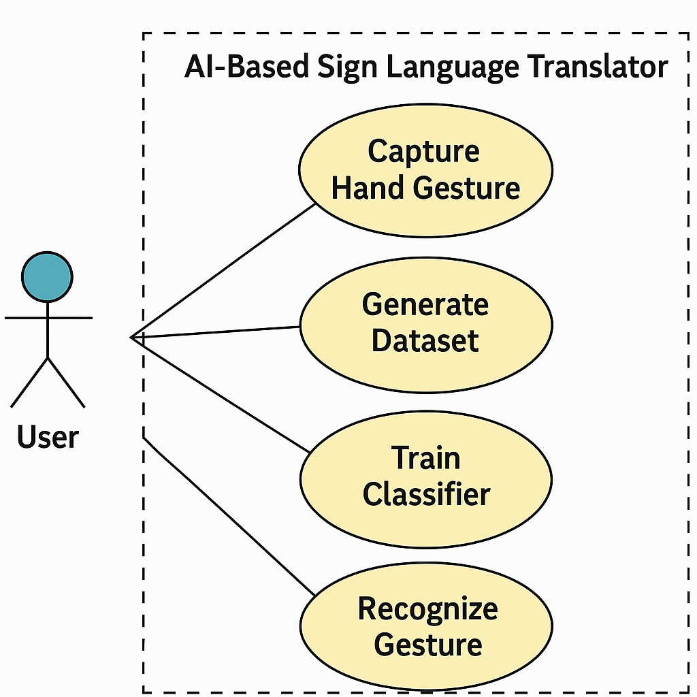

**Fig 5.1: Use Case Diagram for System & User**

## Class Diagram:

The class diagram for the AI-Based Sign Language Translator represents the core components and their interactions within the system. It includes four main classes: DatasetGenerator, ModelTrainer, GestureRecognizer, and AppUI. The DatasetGenerator class handles image capture and labeling using webcam input. ModelTrainer is responsible for extracting hand landmark features and training the KNN classifier. GestureRecognizer loads the trained model and performs real-time prediction based on input from the webcam. AppUI manages the display of predicted gestures to the user. Each class contains attributes relevant to its function (e.g., file paths, model instances) and operations such as captureGesture(), trainModel(), predictGesture(), and displayOutput(). This diagram provides a clear object-oriented structure for maintaining modularity and ease of extension in the system.

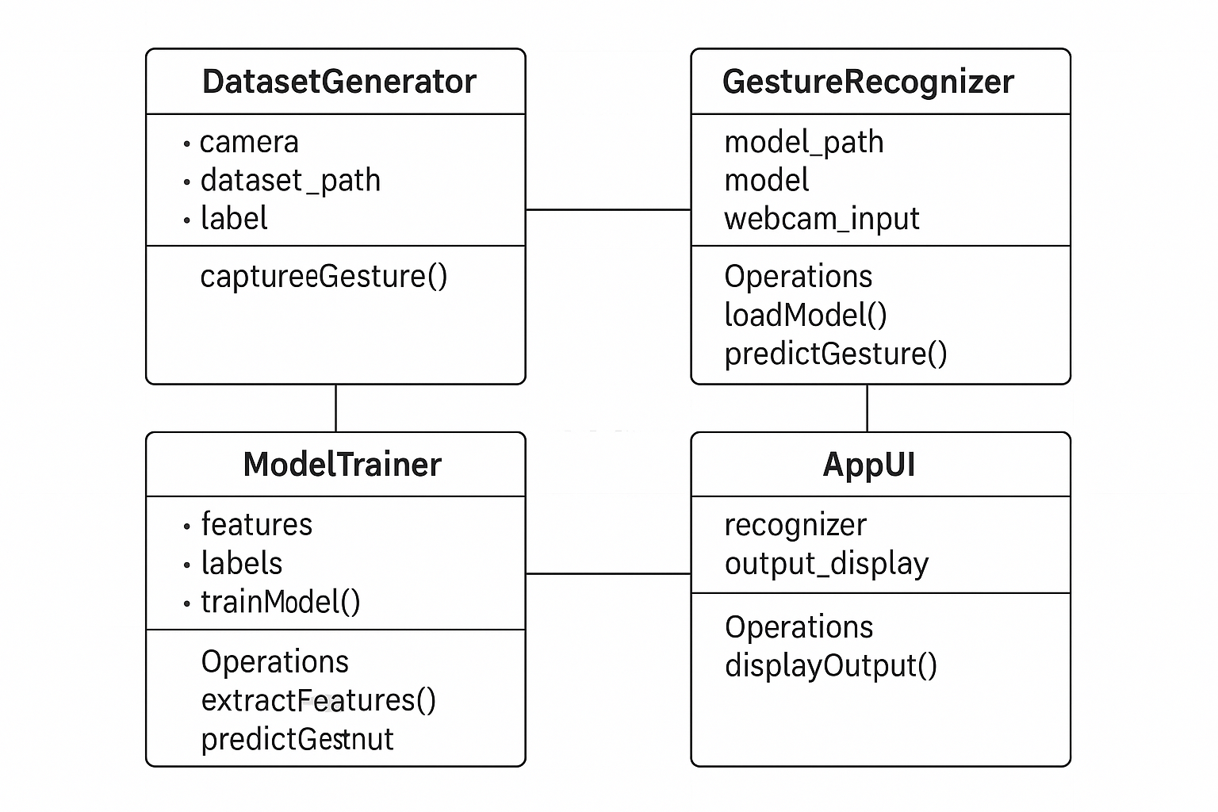

**Fig 5.2: Class Diagram**

## Sequence Diagram:

The sequence diagram outlines the flow of interactions between system components during the real-time gesture recognition process. It begins with the **User**, who performs a hand gesture in front of the **Webcam**. The webcam captures the frames, which are sent to the **MediaPipe Processor** for landmark detection. These landmarks are then passed to the **KNN Classifier**, which loads the trained model and predicts the corresponding sign. The result is then forwarded to the **Display Module**, which presents the recognized gesture as text to the user. This diagram clearly illustrates the time-ordered flow of control and data among components, emphasizing modular and real-time interaction.

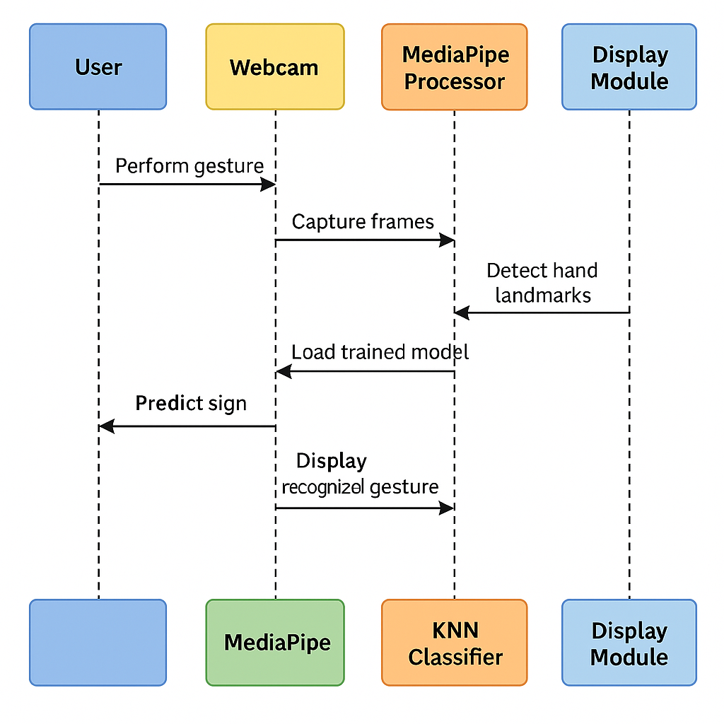

**Fig 5.3: Sequence Diagram for User & System**

## Collaboration Diagram:

The collaboration diagram illustrates the structural organization of system components and how they interact to perform real-time sign recognition. In this system, the **User** interacts with the **Webcam**, which captures gesture input. The data is passed to the **MediaPipe Processor** that extracts hand landmarks. These landmarks are then sent to the **KNN Classifier**, which identifies the gesture using a trained model. Finally, the **Display Module** outputs the recognized gesture in text form. The diagram shows message exchange paths along with the order of communication between components, helping to visualize the interaction flow within a fixed structure.

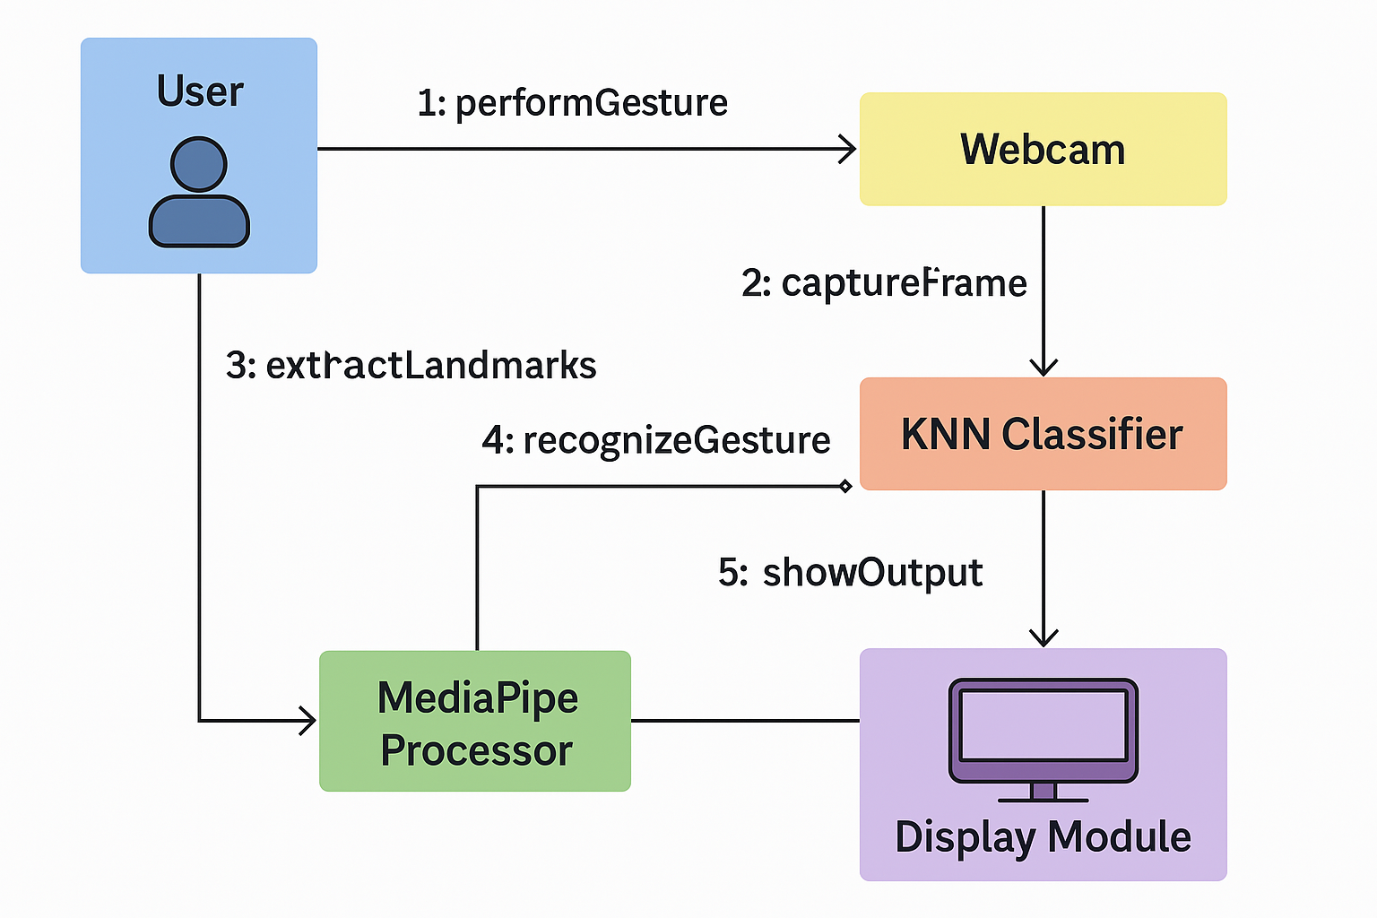

**Fig 5.4: Collaboration Diagram**

## Deployment Diagram:

The deployment diagram depicts the physical architecture of the AI-Based Sign Language Translator system. It shows how software components are deployed across hardware nodes during execution. The system is primarily deployed on a User Device (e.g., a laptop or desktop), which contains essential modules such as the Webcam, Gesture Recognition Module (with MediaPipe and KNN Classifier), and the User Interface Module for displaying output. The trained gesture model (gesture_model.pkl) and dataset images are stored locally. All modules are hosted within the same device, ensuring standalone operation without the need for cloud support, making it suitable for offline usage. This diagram is crucial for visualizing how software components interact with hardware elements in real-world deployment.

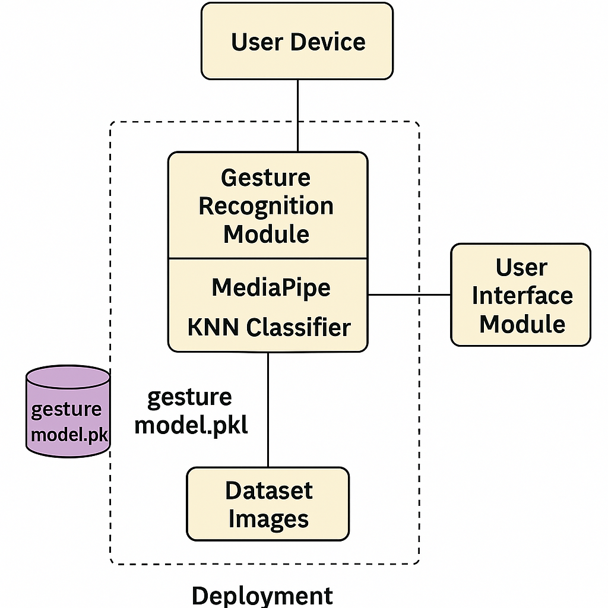

**Fig 5.5: Deployment Diagram**

## Activity Diagram:

The activity diagram illustrates the step-by-step flow of operations in the AI-Based Sign Language Translator system. It begins with the **Start** node, followed by **Capturing Gesture Input** through the webcam. The next steps include **Extracting Hand Landmarks** using MediaPipe, followed by **Preprocessing** and **Classifying the Gesture** using a trained KNN model. Once the gesture is predicted, the system proceeds to **Translate to Text Output** and **Display the Result** on the screen. The process can either end or loop back for continuous recognition. This diagram effectively represents the sequential actions and decisions in the system, making it easy to understand how the components operate together in real time.

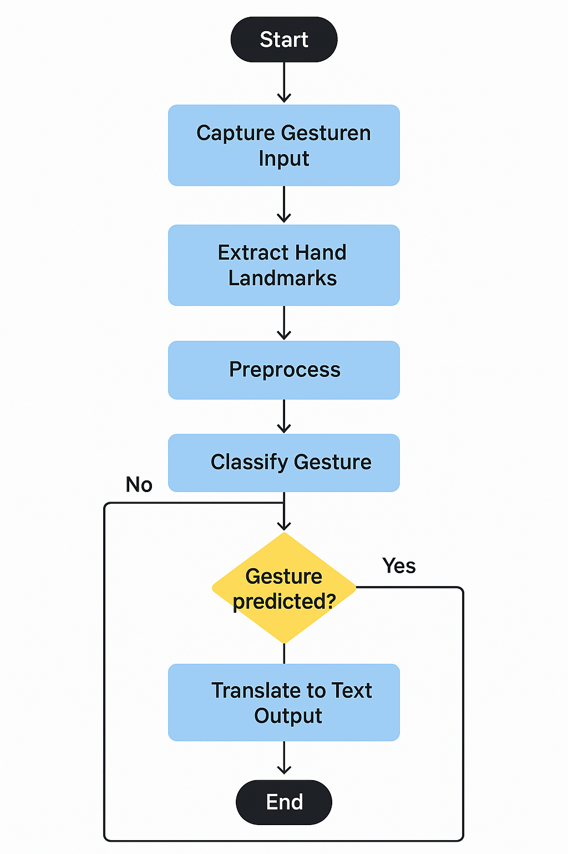

**Fig 5.6: Activity Diagram**

## Component Diagram:

The component diagram illustrates the logical grouping of functional units in the AI-Based Sign Language Translator system. The system is divided into key components such as **Dataset Generator**, **Model Trainer**, **Gesture Recognizer**, and **User Interface**. The **Dataset Generator** component captures labeled images via webcam and stores them in organized folders. The **Model Trainer** processes the dataset, extracts features using MediaPipe, and trains a KNN classifier. The **Gesture Recognizer** uses the trained model (gesture_model.pkl) for real-time prediction of gestures. The **User Interface** component handles display and user interaction. Each of these components interacts through defined interfaces and dependencies, supporting modularity, easy updates, and scalability.

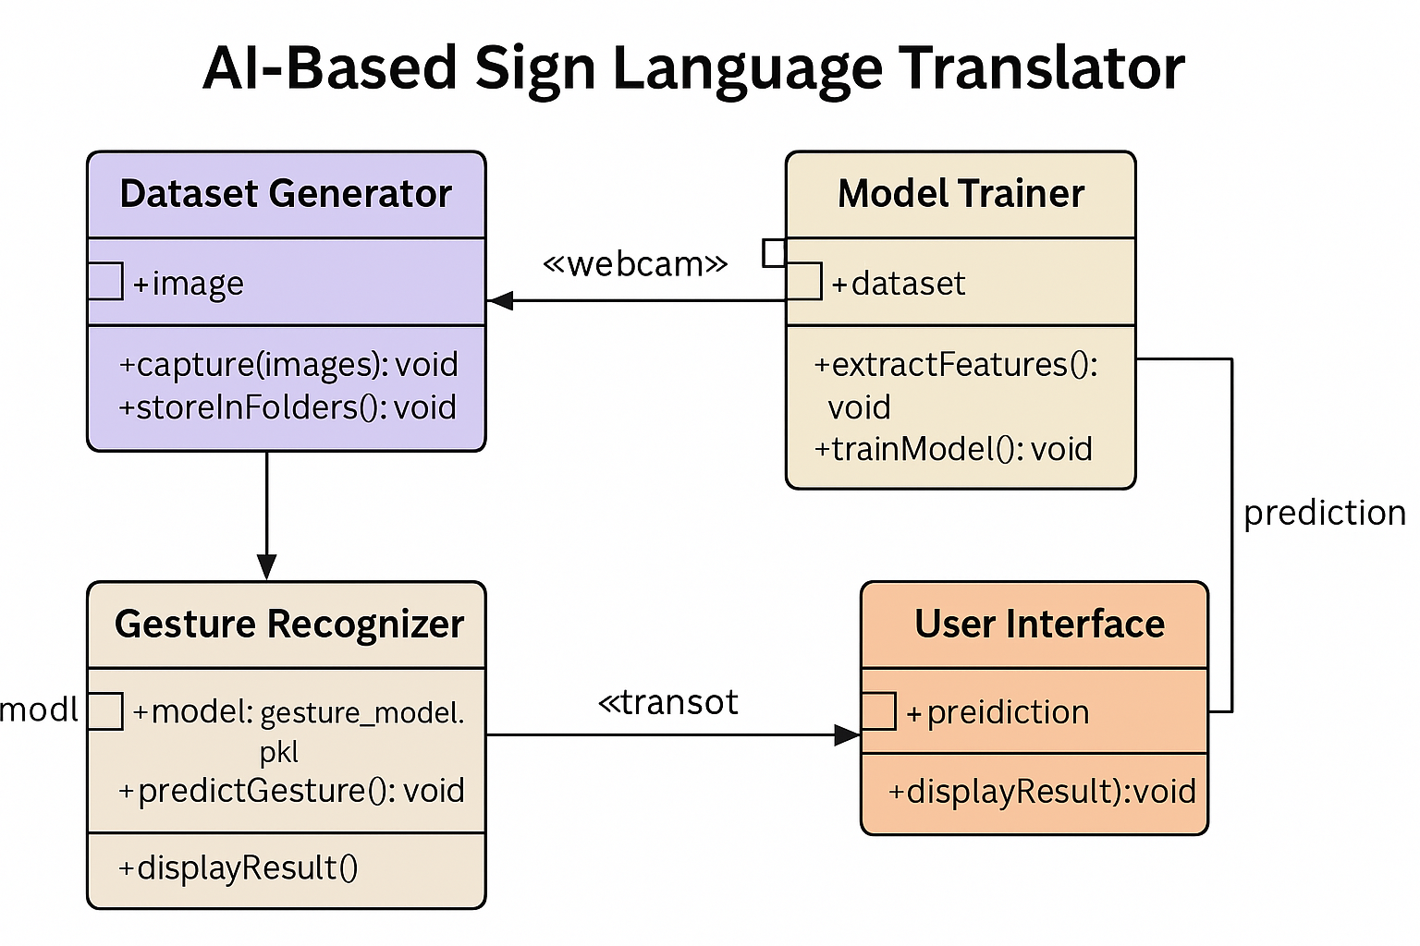

**Fig 5.7: Component Diagram**

## 5.11 ER Diagram:

The ER diagram represents the logical relationships between key data entities in the AI-Based Sign Language Translator system. The main entities include User, Gesture, Dataset, Model, and Prediction. A User can perform multiple Gestures, which are captured and stored as images in the Dataset entity. The Model entity stores information about the trained gesture recognition model, which is linked to the dataset it was trained on. Prediction is generated from the model based on real-time input and is associated with both the model and the gesture. These relationships are essential for understanding how the system manages data from input capture to output prediction and display.

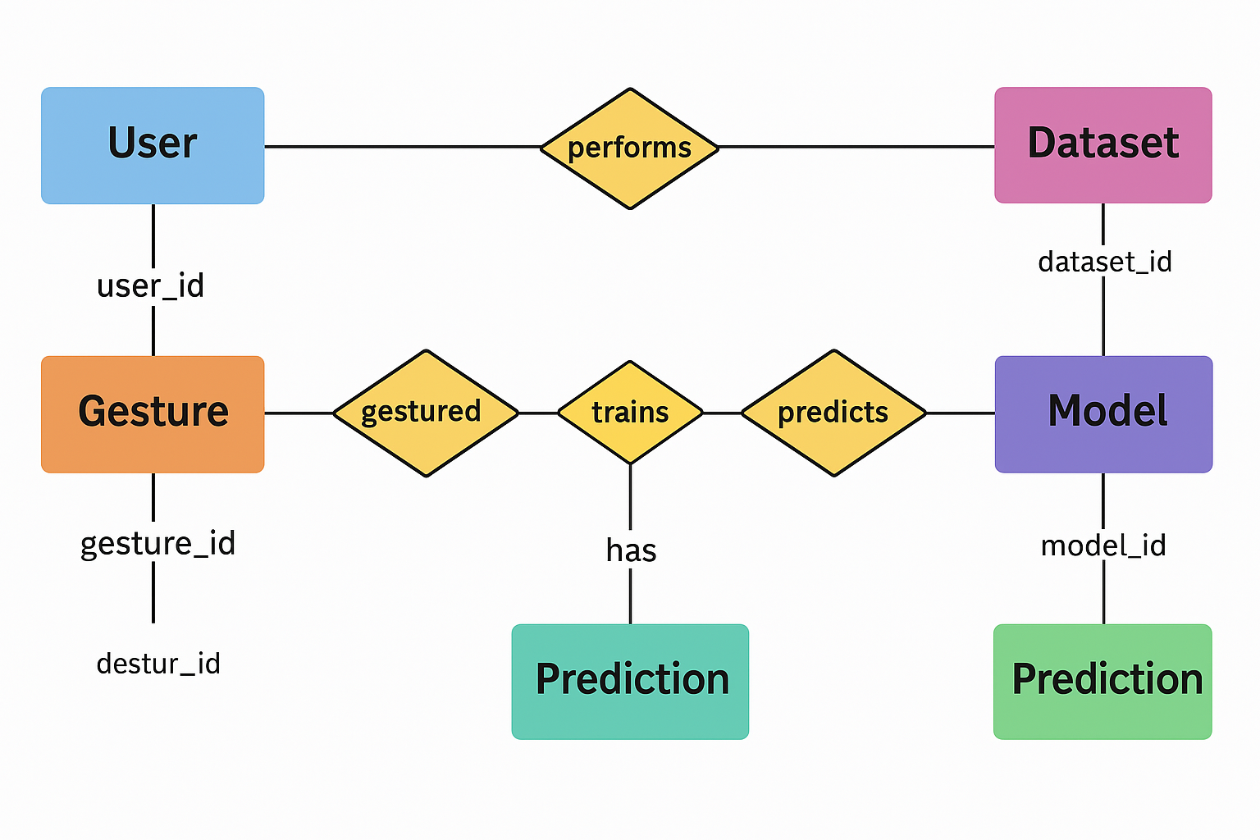

**Fig 5.8: ER Diagram**

## DFD Diagram:

The Level 0 Data Flow Diagram (DFD) for the AI-Based Sign Language Translator system shows the overall flow of data through the system. The primary external entity is the **User**, who performs hand gestures as input. This input flows to the **Gesture Recognition System**, where it is processed by components like the **MediaPipe Processor** for extracting hand landmarks and the **Classifier Module** for identifying the gesture. The result is sent to the **Output Module**, which displays the recognized gesture. Supporting data stores include the **Gesture Dataset** and the **Trained Model**, which are used by internal processes for training and prediction. This DFD illustrates the high-level interactions among system components and data stores.

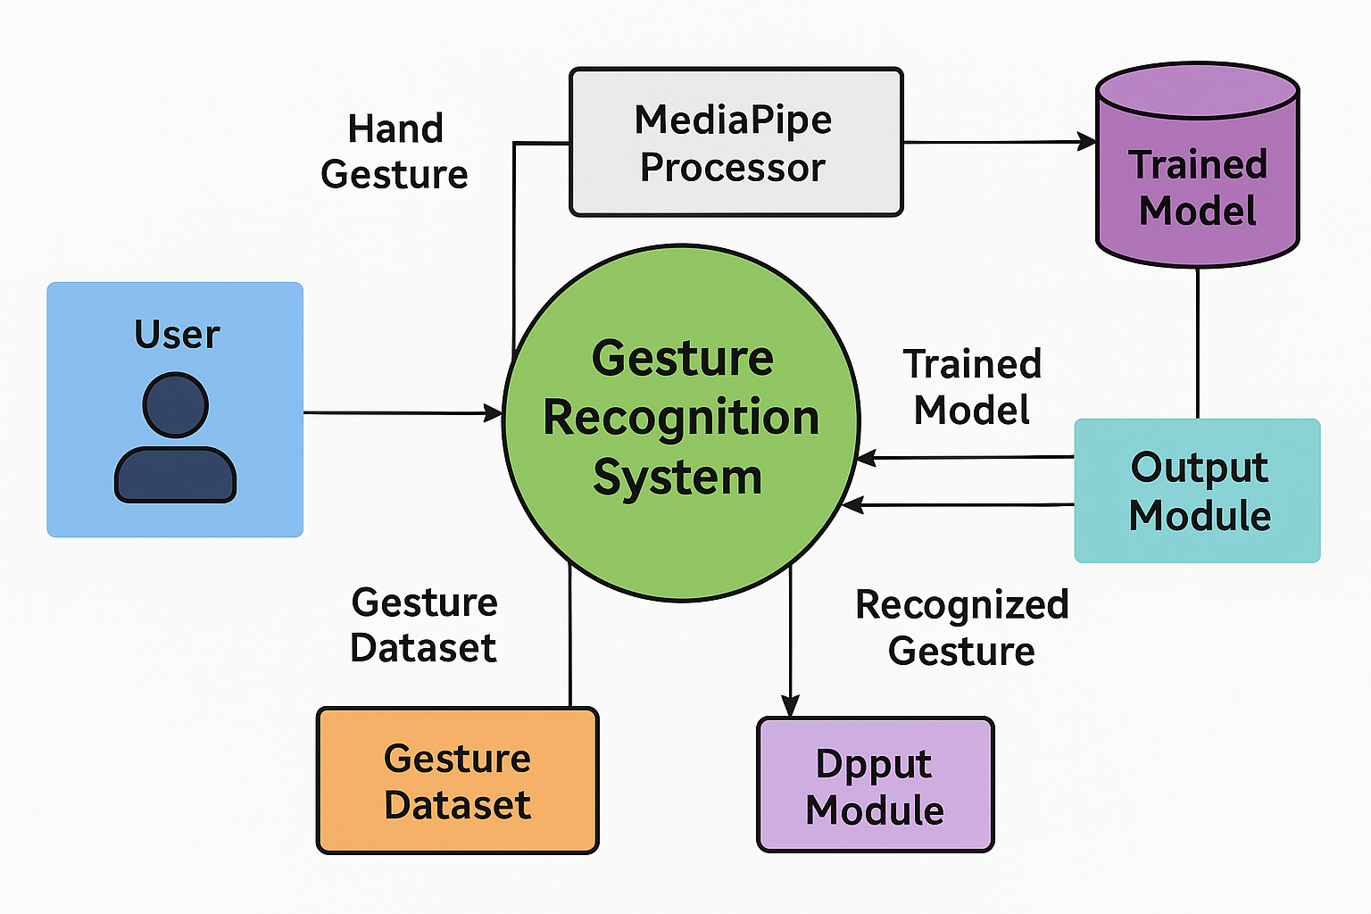

**Fig 5.9: DFD Diagram**

# 6. MODULE IMPLEMENTATION

## App Interface Module

## The AI-Based Sign Language Translator system is implemented using a modular architecture to ensure maintainability, reusability, and scalability. Each module is responsible for a specific part of the sign language recognition pipeline, from capturing gestures to displaying recognized text. The modular breakdown enables efficient development and easy debugging, as each unit functions independently while integrating seamlessly with others. Below is an in-depth explanation of each module involved in the implementation.

## 1. Dataset Generation Module

## This module is responsible for collecting and organizing hand gesture images to create a labeled dataset. It uses a webcam to capture real-time images of static hand gestures and stores them into specific folders corresponding to each sign (e.g., A, B, C, "hi", "thankyou"). A Python script named generate_dataset.py enables this process. It incorporates OpenCV for video capture and frame extraction and MediaPipe to identify hand presence before capturing. The user can press a specific key (e.g., 's') to save the image with the correct label. This labeled image data serves as the training base for the classifier. The structure ensures easy scalability if new signs or gestures need to be added later.

## 2. Model Training Module

## This module processes the labeled dataset and trains a gesture recognition model using machine learning. The training script, train_classifier.py, loads the images from the dataset and extracts 21-point hand landmarks using MediaPipe. These landmarks are converted into numerical vectors (features), which are then used to train a K-Nearest Neighbors (KNN) classifier using scikit-learn. The trained model is evaluated using standard techniques like accuracy scoring and confusion matrices. The final trained model is serialized and saved as gesture_model.pkl in the models/ directory for later use. This modular separation of training allows independent retraining when the dataset is updated or improved.

## 3. Gesture Recognition Module

## This module is the core of the real-time translation system. The script recognize_gesture.py initializes the webcam and continuously captures video frames. MediaPipe is used to detect the user's hand and extract landmarks from each frame. The extracted features are passed into the pre-trained KNN model (loaded from gesture_model.pkl), which then predicts the corresponding gesture. If the gesture is recognized, the label is displayed on the video feed using OpenCV’s text overlay function. This module performs real-time inference, making it crucial for ensuring low-latency and high-accuracy predictions during user interaction.

## 4. Utility Module

## The Utility Module contains reusable helper functions such as hand landmark extraction logic. The hand_landmarks.py script inside the utils/ folder serves this purpose. It provides functions like extract_hand_landmarks(), which detects hand keypoints (x, y coordinates) and formats them for training or recognition. This logic is shared between dataset generation and real-time recognition modules to maintain consistency in how data is processed and interpreted. Any modifications to the landmark extraction logic can be updated centrally in this module, ensuring minimal changes to other scripts.

## 5. Model Storage Module

## This module deals with managing trained models. The model file, gesture_model.pkl, is saved after training and loaded during real-time recognition. It is stored inside the models/ folder. This segregation ensures that model versions can be tracked, tested, and replaced without altering the recognition logic. It also makes it easy to upgrade to more advanced models like RandomForest or SVM if needed.

## 6. User Interface (Display) Module

## This module handles the visual feedback to the user. It displays the video feed and overlays the recognized gesture text in real time. This is crucial for interactive usability, ensuring the user can see the predicted result and reattempt gestures if necessary. The UI is basic but can be enhanced with audio output or gesture confidence levels. Additionally, future versions may integrate speech synthesis using TTS (Text-to-Speech) engines for a more inclusive output experience.

## This modular architecture ensures that each function—from data acquisition to model inference—is logically separated yet seamlessly integrated. It supports easy testing, independent updates, and potential extensions like mobile deployment, dynamic sign recognition, or multilingual gesture sets. The modular design is key to making the system robust, reusable, and adaptable to future enhancements.

## 6.3: Algorithm:

The AI-Based Sign Language Translator system uses a combination of computer vision and machine learning to detect, classify, and display hand gestures. The system follows a step-by-step algorithm that integrates real-time video capture, landmark detection using MediaPipe, and gesture classification using the K-Nearest Neighbors (KNN) algorithm. This structured approach ensures accurate and efficient translation of sign gestures into readable text. The core algorithm is modular and involves multiple stages—from dataset creation to real-time gesture prediction—each designed to handle specific tasks with minimal dependencies and high maintainability.

Phase 1: Dataset Generation

1. Initialize Webcam: Access the computer’s webcam using OpenCV to capture real-time hand gestures.
2. Define Gesture Labels: Predefine a list of gesture classes (e.g., A–Z, numbers, or phrases like “hi”, “thank you”).
3. Start Image Capture Loop:

* Continuously display the video feed.
* Detect the presence of a hand using MediaPipe.
* If the user presses the save key (e.g., ‘s’), capture and save the frame in the directory corresponding to the current gesture label.

1. Store Captured Images: Save the images with unique filenames in respective folders under a dataset/ directory.
2. Repeat: Continue until the required number of images per gesture class is collected.
3. Exit Loop: End image capture when the user chooses to quit.

This phase results in a structured dataset where each image is labeled and ready for training.

Phase 2: Model Training (KNN Classifier)

1. Load Dataset: Iterate through all gesture folders and load each image.
2. Extract Features:

* Use MediaPipe to detect 21 hand landmarks (each with x, y coordinates).
* Flatten the coordinates into a 42-dimensional vector.

1. Label Encoding: Assign a label (e.g., 'a', 'b', 'c') to each feature vector based on its folder.
2. Prepare Data: Create X (features) and y (labels) arrays.
3. Split Dataset: Use train-test split (e.g., 80% training, 20% testing).
4. Train Classifier:

* Initialize a K-Nearest Neighbors (KNN) classifier with a chosen value of k (typically 3 or 5).
* Fit the classifier using training data (X_train, y_train).

1. Evaluate Model:

* Predict using X_test and calculate accuracy.
* Print accuracy or confusion matrix for evaluation.

1. Save Model: Serialize the trained classifier as gesture_model.pkl using pickle or joblib.

The model is now trained and ready to be used in real-time applications.

Phase 3: Real-Time Gesture Recognition

1. Initialize Webcam: Activate webcam feed for continuous frame capture.
2. Load Trained Model: Load gesture_model.pkl into memory.
3. Capture Frames: Read frames one-by-one from the webcam.
4. Detect Hand:

* Use MediaPipe to identify if a hand is present.
* Extract hand landmarks from the frame.

1. Preprocess Input:

* Flatten the 21 landmarks into a 42-dimensional feature vector.
* Format the vector for input into the KNN classifier.

1. Predict Gesture:

* Use the loaded classifier to predict the gesture.
* Retrieve the corresponding gesture label (e.g., “A”, “hello”).

1. Display Output:

* Overlay the predicted gesture label onto the webcam feed using OpenCV.
* Continuously update the display as new frames are captured and processed.

1. Exit Condition:

* If the user presses a predefined key (e.g., 'q'), break the loop and close the webcam feed.

Key Algorithm Highlights

* MediaPipe Landmark Detection: A lightweight, real-time hand tracking system that extracts precise 21-point hand keypoints, robust across different lighting and backgrounds.
* K-Nearest Neighbors: A simple yet powerful classifier that predicts by comparing feature distances, making it ideal for small and medium datasets.
* Modular Scripts: Each stage of the algorithm (dataset, training, prediction) is handled by a separate script, ensuring maintainability and scalability.

This algorithm ensures smooth execution of the sign language translator system in both development and production environments. It can easily be extended to support dynamic signs or deployed on edge devices like Raspberry Pi for portable usage**.**

**Software Installation:**

**Installing Python:**

1. To download and install Python visit the official website of Python <https://www.python.org/downloads/>and choose your version.
2. Once the download is complete, run the exe for install Python. Now click on Install Now.
3. You can see Python installing at this point.
4. When it finishes, you can see a screen that says the Setup was successful. Now click on "Close".

**Installing PyCharm:**

1. To Download PyCharm Visit the Website <https://www.jetbrains.com/pycharm/download/> and click the “DOWNLOAD” link under the Community Section.
2. Once the download is complete,
3. Run the exe for install PyCharm. The setup wizard should have started. Click “Next”.
4. On the next screen, Change the installation path if required. Click “Next”.
5. On the next screen, you can create a desktop shortcut if you want and click on “Next”.
6. Choose the start menu folder. Keep selected Jet Brains and click on “Install”.
7. Wait for the installation to finish.
8. Once installation finished, you should receive a message screen that PyCharm is installed.
9. If you want to go ahead and run it, click the “Run PyCharm Community Edition” box first and click “Finish”.
10. After you click on "Finish," the Following screen will appear.

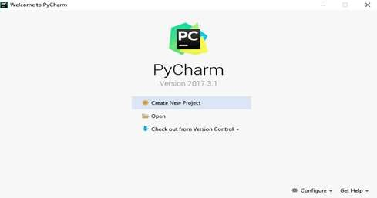

**Fig 6.1: PyCharm welcome page**

1. You need to install some packages to execute your project in a proper way.
2. Open the command prompt/ anaconda prompt or terminal as administrator.
3. The prompt will get open, with specified path, type “pip install package name” which you want to install (like NumPy, pandas, sea born, scikit-learn, Matplotlib, Pyplot)

Ex: Pip install NumPy

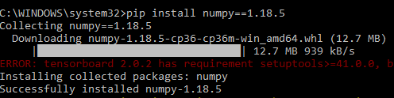

**Fig 6.2: Installing NumPy library INTRODUCTION TO PYTHON:**

* Python

**What Is a Script?**

Up to this point, I have concentrated on the interactive programming capability of Python. This is a very useful capability that allows you to type in a program and to have it executed immediately in an interactive mode

**Scripts are reusable:**

Basically, a script is a text file containing the statements that comprise a Python program. Once you have created the script, you can execute it over and over without having to retype it each time.

**Scripts are editable:**

Perhaps, more importantly, you can make different versions of the script by modifying the statements from one file to the next using a text editor. Then you can execute each of the individual versions. In this way, it is easy to create different programs with a minimum amount of typing.

You will need a text editor Just about any text editor will suffice for creating Python script files. You can use *Microsoft Notepad, Microsoft WordPad, Microsoft Word,* or just about any word processor if you want to.

**Difference between a script and a program:**

**Script:**

Scripts are distinct from the core code of the application, which is usually written in a different language, and are often created or at least modified by the end-user. Scripts are often interpreted from source code or byte code, whereas the applications they control are traditionally compiled to native machine code.

**Program:**

The program has an executable form that the computer can use directly to execute the instructions.

The same program in its human-readable source code form, from which executable programs are derived (e.g., compiled)

**Python:**

What is Python? Chances you are asking yourself this. You may have found this book because you want to learn to program but don’t know anything about programming languages. Or you may have heard of programming languages like C, C++, C#, or Java and want to know what Python is and how it compares to “big name” languages. Hopefully I can explain it for you.

**Python concepts:**

If you’re not interested in the how’s and whys of Python, feel free to skip to the next chapter. In this chapter I will try to explain to the reader why I think Python is one of the best languages available and why it’s a great one to start programming with.

* Open-source general-purpose language.
* Object Oriented, Procedural, Functional
* Easy to interface with C/ObjC/Java/Fortran
* Easy-is to interface with C++ (via SWIG)
* Great interactive environment
* Great interactive environment

Python is a high-level, interpreted, interactive and object-oriented scripting language. Python is designed to be highly readable. It uses English keywords frequently where as other languages use punctuation, and it has fewer syntactical constructions than other languages.

* Python is Interpreted − Python is processed at runtime by the interpreter. You do not need to compile your program before executing it. This is similar to PERL and PHP.
* Python is Interactive − you can actually sit at a Python prompt and interact with the interpreter directly to write your programs.
* Python is Object-Oriented − Python supports Object-Oriented style or technique of programming that encapsulates code within objects.
* Python is a Beginner's Language − Python is a great language for the beginner- level programmers and supports the development of a wide range of applications from simple text processing to WWW browsers to games.

**History of Python:**

Python was developed by Guido van Possum in the late eighties and early nineties at the National Research Institute for Mathematics and Computer Science in the Netherlands.

Python is derived from many other languages, including ABC, Modula-3, C, C++, Algol-68, Smalltalk, and UNIX shell and other scripting languages.

Python is copyrighted. Like Perl, Python source code is now available under the GNU General Public License (GPL).

Python is now maintained by a core development team at the institute, although Guido van Possum still holds a vital role in directing its progress.

**Python Features:**

Python's features include −

* Easy-to-learn − Python has few keywords, simple structure, and a clearly defined syntax. This allows the student to pick up the language quickly.
* Easy-to-read − Python code is more clearly defined and visible to the eyes.
* Easy-to-maintain − Python's source code is fairly easy-to-maintained.
* A broad standard library − Python's bulk of the library is very portable and cross- platform compatible on UNIX, Windows, and Macintosh.
* Interactive Mode − Python has support for an interactive mode which allows interactive testing and debugging of snippets of code.
* Portable − Python can run on a wide variety of hardware platforms and has the same interface on all platforms.
* Extendable − you can add low-level modules to the Python interpreter. These modules enable programmers to add to or customize their tools to be more efficient.
* Databases − Python provides interfaces to all major commercial databases.
* GUI Programming − Python supports GUI applications that can be created and ported to many system calls, libraries and windows systems, such as Windows MFC, Macintosh, and the X Window system of Unix.
* Scalable − Python provides a better structure and support for large programs than shell scripting.
* Apart from the above-mentioned features, Python has a big list of good features, few are listed below −
* It supports functional and structured programming methods as well as OOP.
* It can be used as a scripting language or can be compiled to byte-code for building large applications.
* It provides very high-level dynamic data types and supports dynamic type checking.
* IT supports automatic garbage collection.

**Dynamic vs. Static:**

* Types Python is a dynamic-typed language. Many other languages are static typed, such as C/C++ and Java. A static typed language requires the programmer to explicitly tell the computer what type of “thing” each data value is.
* For example, in C if you had a variable that was to contain the price of something, you would have to declare the variable as a “float” type.
* This tells the compiler that the only data that can be used for that variable must be a floating-point number, i.e. a number with a decimal point.
* If any other data value was assigned to that variable, the compiler would give an error when trying to compile the program.
* Python, however, doesn’t require this. You simply give your variables names and assign values to them. The interpreter takes care of keeping track of what kinds of objects your program is using. This also means that you can change the size of the values as you develop the program. Say you have another decimal number (a.k.a. a floating-point number) you need in your program. With a static typed language, you have to decide the memory size the variable can take when you first initialize that variable. A double is a floating-point value that can handle a much larger number than a normal float (the actual memory sizes depend on the operating environment).
* If you declare a variable to be a float but later on assign a value that is too big to it, your program will fail; you will have to go back and change that variable to be a double.
* With Python, it doesn’t matter. You simply give it whatever number you want and Python will take care of manipulating it as needed.
* For example, say you are dividing two numbers. One is a floating-point number and one is an integer. Python realizes that it’s more accurate to keep track of decimals so it automatically calculates the result as a floating-point number

**Variables:**

Variables are nothing but reserved memory locations to store values. This means that when you create a variable you reserve some space in memory.

Based on the data type of a variable, the interpreter allocates memory and decides what can be stored in the reserved memory. Therefore, by assigning different data types to variables, you can store integers, decimals or characters in these variables.

**Standard Data Types:**

The data stored in memory can be of many types. For example, a person's age is stored as a numeric value and his or her address is stored as alphanumeric characters. Python has various standard data types that are used to define the operations possible on them and the storage method for each of them.

Python has five standard data types −

* Numbers
* String
* List
* Tuple
* Dictionary

**Python Numbers:**

Number data types store numeric values. Number objects are created when you assign a value to them

**Python Strings:**

Strings in Python are identified as a contiguous set of characters represented in the quotation marks. Python allows for either pairs of single or double quotes. Subsets of strings can be taken using the slice operator ([ ] and [:]) with indexes starting at 0 in the beginning of the string and working their way from -1 at the end.

**Python Lists:**

Lists are the most versatile of Python’s compound data types. A list contains items separated by commas and enclosed within square brackets ([]). To some extent, lists

are similar to arrays in C. One difference between them is that all the items belonging to a list can be of different data type.

The values stored in a list can be accessed using the slice operator ([ ] and [:]) with indexes starting at 0 in the beginning of the list and working their way to end -1. The plus (+) sign is the list concatenation operator, and the asterisk (*) is the repetition operator.

**Python Tuples:**

A tuple is another sequence data type that is similar to the list. A tuple consists of a number of values separated by commas. Unlike lists, however, tuples are enclosed within parentheses.

The main differences between lists and tuples are: Lists are enclosed in brackets ([ ]) and their elements and size can be changed, while tuples are enclosed in parentheses (( )) and cannot be updated. Tuples can be thought of as read-only lists.

**Python Dictionary:**

Python's dictionaries are kind of hash table type. They work like associative arrays or hashes found in Perl and consist of key-value pairs. A dictionary key can be almost any Python type, but are usually numbers or strings. Values, on the other hand, can be any arbitrary Python object.

Dictionaries are enclosed by curly braces ({ }) and values can be assigned and accessed using square braces ([]).

**Different modes in python:**

Python has two basic modes: normal and interactive.

The normal mode is the mode where the scripted and finished .pie files are run in the Python interpreter.

Interactive mode is a command line shell which gives immediate feedback for each statement, while running previously fed statements in active memory. As new lines are fed into the interpreter, the fed program is evaluated both in part and in whole

**20 Python libraries:**

1. Requests. The most famous http library written by Kenneth remits. It’s a must have for every python developer.
2. Scrappy. If you are involved in web scraping then this is a must have library for

you. After using this library, you won’t use any other.

1. Python. A guy toolkit for python. I have primarily used it in place of tinder. You will really love it.
2. Pillow. A friendly fork of PIL (Python Imaging Library). It is more user friendly than PIL and is a must have for anyone who works with images.
3. SQL Alchemy. A database library. Many love it and many hate it. The choice is yours.
4. Beautiful Soup. I know it’s slow but this xml and html parsing library is very useful for beginners.
5. Twisted. The most important tool for any network application developer. It has a very beautiful ape and is used by a lot of famous python developers.
6. Numbly. How can we leave this very important library? It provides some advance math functionalities to python.
7. Skippy. When we talk about numbly then we have to talk about spicy. It is a library of algorithms and mathematical tools for python and has caused many scientists to switch from ruby to python.
8. Matplotlib. A numerical plotting library. It is very useful for any data scientist or any data analyzer.
9. Pygame. Which developer does not like to play games and develop them? This library will help you achieve your goal of 2d game development.
10. Piglet. A 3d animation and game creation engine. This is the engine in which the famous [python port](https://github.com/fogleman/Minecraft) of mine craft was made
11. Pit. A GUI toolkit for python. It is my second choice after python for developing GUIs for my python scripts.
12. Pit. Another python GUI library. It is the same library in which the famous Bit torrent client is created.
13. Scaly. A packet sniffer and analyzer for python made in python.
14. Pywin32. A python library which provides some useful methods and classes for interacting with windows.
15. Notch. Natural Language Toolkit –I realize most people won’t be using this one,but it’s generic enough. It is a very useful library if you want to manipulate strings.

But its capacity is beyond that. Do check it out.

1. Nose. A testing framework for python. It is used by millions of python developers. It is a must have if you do test driven development.
2. Simply. Simply can-do algebraic evaluation, differentiation, expansion, complex numbers, etc. It is contained in a pure Python distribution.
3. IPython. I just can’t stress enough how useful this tool is. It is a python prompt on steroids. It has completion, history, shell capabilities, and a lot more. Make sure that you take a look at it.

**Pandas:**

* Pandas provide us with many Series and Data Frames. It allows you to easily organize, explore, represent, and manipulate data.
* Smart alignment and indexing featured in Pandas offer you a perfect organization and data labeling.
* Pandas has some special features that allow you to handle missing data or value with a proper measure.
* This package offers you such a clean code that even people with no or basic knowledge of programming can easily work with it.
* It provides a collection of built-in tools that allows you to both read and write data in different web services, data-structure, and databases as well.
* Pandas can support JSON, Excel, CSV, HDF5, and many other formats. In fact, you can merge different databases at a time with Pandas.

**Numpy:**

* Arrays of Numpy offer modern mathematical implementations on huge amount of data. Numpy makes the execution of these projects much easier and hassle-free.
* Numpy provides masked arrays along with general array objects. It also comes with functionalities such as manipulation of logical shapes, discrete Fourier transform, general linear algebra, and many more.
* While you change the shape of any N-dimensional arrays, Numpy will create new

arrays for that and delete the old ones.

* This python package provides useful tools for integration. You can easily integrate Numpy with programming languages such as C, C++, and Fortran code.
* Numpy provides such functionalities that are comparable to MATLAB. They both allow users to get faster with operations.

**Pymysql:**

* PyMySQL is a database connector for Python, libraries to enable Python programs to talk to a MySQL server.
* Access to the port settings through Python properties.
* PyMySQL is a pure Python MySQL driver, first written as a rough port of the MySQL-Python driver.
* PyMySQL meets all of criterion for a driver.
* It is fully open source, hosted on Github, released on Pypi, is actively maintained.
* It is written in pure Python so is eventlet-monkeypatch compatible, and is fully Python 3 compatible.

**Scikit-Learn:**

* The random module is a simple and efficient tool for predictive data analysis
* Accessible to everybody and reusable in various contexts
* The library is focused on modeling data. It is not focused on loading, manipulating and summarizing data. For these features, refer to NumPy and Pandas.
* The functionality that scikit-learn provides include:
* Regression, including Linear and Logistic Regression
* Classification, including K-Nearest Neighbors
* Clustering, including K-Means and K-Means++
* Model selection
* Preprocessing, including Min-Max Normalization

**Python classes and objects:**

These are the building blocks of OOP. class creates a new object. This object can be anything, whether an abstract data concept or a model of a physical object, e.g., a chair. Each class has individual characteristics unique to that class, including variables and methods. Classes are very powerful and currently “the big thing” in most programming languages. Hence, there are several chapters dedicated to OOP later in the book.

The class is the most basic component of object-oriented programming. Previously, you learned how to use functions to make your program do something.

Now will move into the big, scary world of Object-Oriented Programming (OOP). To be honest, it took me several months to get a handle on objects.

When I first learned C and C++, I did great; functions just made sense for me.

Having messed around with BASIC in the early ’90s, I realized functions were just like subroutines so there wasn’t much new to learn.

However, when my C++ course started talking about objects, classes, and all the new features of OOP, my grades definitely suffered.

Once you learn OOP, you’ll realize that it’s actually a pretty powerful tool. Plus many Python libraries and APIs use classes, so you should at least be able to understand what the code is doing.

One thing to note about Python and OOP: it’s not mandatory to use objects in your code in a way that works best; maybe you don’t need to have a full-blown class with initialization code and methods to just return a calculation. With Python, you can get as technical as you want.

As you’ve already seen, Python can do just fine with functions. Unlike languages such as Java, you aren’t tied down to a single way of doing things; you can mix functions and classes as necessary in the same program. This lets you build the code

Objects are an encapsulation of variables and functions into a single entity. Objects get their variables and functions from classes.

**Here’s a brief list of Python OOP ideas:**

* The class statement creates a class object and gives it a name. This creates a new namespace.
* Assignments within the class create class attributes. These attributes are accessed by qualifying the name using dot syntax: Class Name. Attribute.
* Class attributes export the state of an object and its associated behavior. These attributes are shared by all instances of a class.
* Calling a class (just like a function) creates a new instance of the class.
* This is where the multiple copies part comes in.
* Each instance gets ("inherits") the default class attributes and gets its own namespace. This prevents instance objects from overlapping and confusing the program.
* Using the term self identifies a particular instance, allowing for per-instance attributes. This allows items such as variables to be associated with a particular instance.

**Inheritance:**

First off, classes allow you to modify a program without really making changes to it.

To elaborate, by subclassing a class, you can change the behavior of the program by simply adding new components to it rather than rewriting the existing components.

As we’ve seen, an instance of a class inherits the attributes of that class.

However, classes can also inherit attributes from other classes. Hence, a subclass inherits from a superclass allowing you to make a generic superclass that is specialized via subclasses.

The subclasses can override the logic in a superclass, allowing you to change the behavior of your classes without changing the superclass at all.

**Operator Overloads:**

Operator overloading simply means that objects that you create from classes can respond to actions (operations) that are already defined within Python, such as

addition, slicing, printing, etc.

Even though these actions can be implemented via class methods, using overloading ties the behavior closer to Python’s object model and the object interfaces are more consistent to Python’s built-in objects, hence overloading is easier to learn and use. User-made classes can override nearly all of Python’s built-in operation methods. **Exceptions:**

I’ve talked about exceptions before but now I will talk about them in depth. Essentially, exceptions are events that modify program’s flow, either intentionally or due to errors.

They are special events that can occur due to an error, e.g. trying to open a file that doesn’t exist, or when the program reaches a marker, such as the completion of a loop.

Exceptions, by definition, don’t occur very often; hence, they are the "exception to the rule" and a special class has been created for them. Exceptions are everywhere in Python.

Virtually every module in the standard Python library uses them, and Python itself will raise them in a lot of different circumstances.

Here are just a few examples:

Accessing a non−existent dictionary key will raise a Key Error exception.  Searching a list for a non−existent value will raise a Value Error exception

Calling a non−existent method will raise an Attribute Error exception.  Referencing a non−existent variable will raise a Name Error exception.

Mixing data types without coercion will raise a Type Error exception.

One use of exceptions is to catch a fault and allow the program to continue working; we have seen this before when we talked about files.

This is the most common way to use exceptions. When programming with the Python command line interpreter, you don’t need to worry about catching exceptions.

Your program is usually short enough to not be hurt too much if an exception occurs. Plus, having the exception occur at the command line is a quick and easy way to tell

if your code logic has a problem.

However, if the same error occurred in your real program, it will fail and stop working. Exceptions can be created manually in the code by raising an exception.

It operates exactly as a system-caused exceptions, except that the programmer is doing it on purpose. This can be for a number of reasons. One of the benefits of using exceptions is that, by their nature, they don’t put any overhead on the code processing.

Because exceptions aren’t supposed to happen very often, they aren’t processed until they occur.

Exceptions can be thought of as a special form of the if/elif statements. You can realistically do the same thing with if blocks as you can with exceptions.

However, as already mentioned, exceptions aren’t processed until they occur; if blocks are processed all the time.

Proper use of exceptions can help the performance of your program.

The more infrequent the error might occur, the better off you are to use exceptions; using if blocks requires Python to always test extra conditions before continuing.

Exceptions also make code management easier: if your programming logic is mixed in with error-handling if statements, it can be difficult to read, modify, and debug your program.

**User-Defined Exceptions:**

I won’t spend too much time talking about this, but Python does allow for a programmer to create his own exceptions.

You probably won’t have to do this very often but it’s nice to have the option when necessary.

However, before making your own exceptions, make sure there isn’t one of the built- in exceptions that will work for you.

They have been "tested by fire" over the years and not only work effectively, they have been optimized for performance and are bug-free.

Making your own exceptions involves object-oriented programming, which will be covered in the next chapter

To make a custom exception, the programmer determines which base exception to use as the class to inherit from, e.g., making an exception for negative numbers or one for imaginary numbers would probably fall under the Arithmetic Error exception class.

**Python modules:**

Python allows us to store our code in files (also called modules). This is very useful for more serious programming, where we do not want to retype a long function definition from the very beginning just to change one mistake. In doing this, we are essentially defining our own modules, just like the modules defined already in the **Python library:**

To support this, Python has a way to put definitions in a file and use them in a script or in an interactive instance of the interpreter. Such a file is called a *module*; definitions from a module can be *imported* into other modules or into the *main* module.

**Testing code:**

* As indicated above, code is usually developed in a file using an editor. To test the code, import it into a Python session and try to run it.
* Usually there is an error, so you go back to the file, make a correction, and test again.
* This process is repeated until you are satisfied that the code works. This entire process is known as the development cycle.
* There are two types of errors that you will encounter. Syntax errors occur when the form of some command is invalid.
* This happens when you make typing errors such as misspellings, or call something by the wrong name, and for many other reasons. Python will always give an error message for a syntax error.
* It is very important step while we testing the code if there is any error in the code we can rectify it.

**Functions in Python:**

It is possible, and very useful, to define our own functions in Python. Generally speaking, if you need to do a calculation only once, then use the interpreter. But when you or others have need to perform a certain type of calculation many times, then define a function.

You use functions in programming to bundle a set of instructions that you want to use repeatedly or that, because of their complexity, are better self-contained in a sub-program and called when needed. That means that a function is a piece of code written to carry out a specified task.

To carry out that specific task, the function might or might not need multiple inputs. When the task is carried out, the function can or cannot return one or more values.

There are three types of functions in python:

Help() min(), print().Namespaces in Python are implemented as Python dictionaries, this means it is a mapping from names (keys) to objects (values). The user doesn't have to know this to write a Python program and when using namespaces.

**Python Namespace:**

Generally speaking, a namespace (sometimes also called a context) is a naming system for making names unique to avoid ambiguity. Everybody knows a name spacing system from daily life, i.e., the naming of people in first name and family name (surname).

An example is a network: each network device (workstation, server, printer, ...) needs a unique name and address. Yet another example is the directory structure of file systems.

The same file name can be used in different directories, the files can be uniquely accessed via the pathnames. Many programming languages use namespaces or contexts for identifiers. An identifier defined in a namespace is associated with that namespace.

This way, the same identifier can be independently defined in multiple namespaces. (Like the same file names in different directories) Programming languages, which support namespaces, may have different rules that determine to which namespace an identifier belongs.

Namespaces in Python are implemented as Python dictionaries, this means it is a mapping from names (keys) to objects (values). The user doesn't have to know this to write a Python program and when using namespaces.

Some namespaces in Python:

* **global names** of a module
* **local names** in a function or method invocation
* **built-in names**: this namespace contains built-in functions (e.g. abs(), cmp(), ...) and built-in exception names

**Garbage Collection:**

Garbage Collector exposes the underlying memory management mechanism of Python, the automatic garbage collector. The module includes functions for controlling how the collector operates and to examine the objects known to the system, either pending collection or stuck in reference cycles and unable to be freed.

**Python XML Parser:**

XML is a portable, open-source language that allows programmers to develop applications that can be read by other applications, regardless of operating system and/or developmental language.

What is XML? The Extensible Markup Language XML is a markup language much like HTML or SGML.

This is recommended by the World Wide Web Consortium and available as an open standard.

XML is extremely useful for keeping track of small to medium amounts of data without requiring a SQL-based backbone.

XML Parser Architectures and APIs The Python standard library provides a minimal

but useful set of interfaces to work with XML.

The two most basic and broadly used APIs to XML data are the SAX and DOM interfaces.

Simple API for XML SAX: Here, you register callbacks for events of interest and then let the parser proceed through the document.

This is useful when your documents are large or you have memory limitations, it parses the file as it reads it from disk and the entire file is never stored in memory.

Document Object Model DOM API: This is a World Wide Web Consortium recommendation wherein the entire file is read into memory and stored in a hierarchical tree − based form to represent all the features of an XML document.

SAX obviously cannot process information as fast as DOM can when working with large files. On the other hand, using DOM exclusively can really kill your resources, especially if used on a lot of small files.

SAX is read-only, while DOM allows changes to the XML file. Since these two different APIs literally complement each other, there is no reason why you cannot use them both for large projects.

# 7. SOURCE CODE

### requirements.txt ###

flask

xgboost

numpy

pandas

optuna

scikit-learn

imbalanced-learn

requests

scikit-learn

### local_init.bat ###

@echo off

echo Initializing virtual environment and installing dependencies...

python -m venv venv

call venv\Scripts\activate

pip install --upgrade pip

pip install -r requirements.txt

echo Training the model...

python Model\model.py

echo Setup complete. Run the application using local_run.bat

### local_init.sh ###

#!/bin/bash

echo "Initializing virtual environment and installing dependencies..."

python3 -m venv venv

source venv/bin/activate

pip install --upgrade pip

pip install -r requirements.txt

echo "Training the model..."

python Model/model.py

echo "Setup complete. Run the application using local_run.sh"

### model.py ###

import numpy as np

import pandas as pd

from sklearn.model_selection import train_test_split

from sklearn.preprocessing import StandardScaler

from imblearn.over_sampling import SMOTE

from sklearn.feature_selection import SelectFromModel

import xgboost as xgb

from xgboost import XGBClassifier

import optuna

from sklearn.metrics import (

accuracy_score,

recall_score,

f1_score,

precision_score,

roc_auc_score,

mean_squared_error,

make_scorer,

)

from sklearn.model_selection import cross_val_score, GridSearchCV

import pickle

import json

import requests

# Load the Dataset

df = pd.read_csv(r"C:\Users\viswa\OneDrive\Desktop\Heart-Attack-Prediction-Model-main\Heart-Attack-Prediction-Model-main-Copy\Dataset\heart_attack_prediction_dataset.csv")

# Printing the dataset

# df.head()

"""Setting column 'Blood Pressure'

Splitting Between Diastolic and Systolic Blood Pressure"""

df["BP_Systolic"] = df["Blood Pressure"].apply(lambda x: x.split("/")[0])

df["BP_Diastolic"] = df["Blood Pressure"].apply(lambda x: x.split("/")[1])

# Converting object(here category present) into integer

mapping = {"Unhealthy": -1, "Average": 0, "Healthy": 1}

df["Diet"] = df["Diet"].map(mapping)

# Converting object(here category present) into integer

mapping = {"Male": -1, "Female": 0}

df["Sex"] = df["Sex"].map(mapping)

"""Converting 'Object' and 'Boolean' Datatype into int"""

cat_columns = ["BP_Systolic", "BP_Diastolic"]

df[cat_columns] = df[cat_columns].astype(int)

X = df.drop(

[

"Patient ID",

"Blood Pressure",

"Country",

"Continent",

"Hemisphere",

"Heart Attack Risk",

],

axis=1,

)

y = df["Heart Attack Risk"]

sm = SMOTE(random_state=42)

X_oversampled, y_oversampled = sm.fit_resample(X, y)

# Splitting Data into train set and test set

X_train, X_test, y_train, y_test = train_test_split(

X_oversampled, y_oversampled, test_size=0.2, random_state=42

)

scaler = StandardScaler()

X_train = scaler.fit_transform(X_train)

X_test = scaler.transform(X_test)

selector = SelectFromModel(xgb.XGBClassifier()).fit(X_train, y_train)

selected_features = selector.get_support()

X_train_selected = X_train[:, selected_features]

X_test_selected = X_test[:, selected_features]

# Creating New feature lists according to top 10 features only (provided in the last of the notebook)[For XGboost/RandomForest only]

X_new = df.drop(

[

"Patient ID",

"Blood Pressure",

"Country",

"Continent",

"Hemisphere",

"Heart Attack Risk",

"Sex",

"Cholesterol",

"Obesity",

"Previous Heart Problems",

"Medication Use",

"Stress Level",

"Sedentary Hours Per Day",

"Income",

"BMI",

"Triglycerides",

"Physical Activity Days Per Week",

"Sleep Hours Per Day",

"BP_Systolic",

"BP_Diastolic",

],

axis=1,

)

y_new = df["Heart Attack Risk"]

print(X_new.info())

# Oversample the minority class using SMOTE

sm = SMOTE(random_state=42)

X_new_oversampled, y_new_oversampled = sm.fit_resample(X_new, y_new)

# Again check the distribution of class

check_distribution = y_new_oversampled.value_counts()

print("Class-Distribution\n", check_distribution)

# Splitting Data into train set and test set

X_new_train, X_new_test, y_new_train, y_new_test = train_test_split(

X_new_oversampled, y_new_oversampled, test_size=0.2, random_state=42

)

# Feature Scaling to standarize the features(such that mean is zero and variance is one.)

scaler = StandardScaler()

X_new_train = scaler.fit_transform(X_new_train)

X_new_test = scaler.transform(X_new_test)

# Making the XGboost model for our heart attack risk prediction (Model-1) [Train with selected features]

def objective(trial):

params = {

"max_depth": trial.suggest_int("max_depth", 3, 10),

"n_estimators": trial.suggest_int("n_estimators", 100, 500),

"learning_rate": trial.suggest_float("learning_rate", 0.01, 0.5),

}

model = xgb.XGBClassifier(params)

model.fit(X_new_train, y_new_train)

y_pred = model.predict(X_new_test)

accuracy = accuracy_score(y_new_test, y_pred)

return accuracy

# Run Optuna to find the best hyperparameters

study = optuna.create_study(direction="maximize")

study.optimize(objective, n_trials=100)

# Get the best hyperparameters

best_params = study.best_params

# Train the model with the best hyperparameters

model = xgb.XGBClassifier(best_params)

model.fit(X_new_train, y_new_train)

y_pred = model.predict(X_new_test)

# Evaluate model performance

# accuracy = accuracy_score(y_test, y_pred)

# print('Accuracy with tuned hyperparameters:', accuracy)

# Perform 5-fold cross-validation for XGBOOST model

scores = cross_val_score(model, X_new_train, y_new_train, cv=5)

print("Cross-validation scores:", scores)

# Calculate the mean cross-validation score

mean_score = np.mean(scores)

print("Mean cross-validation score:", mean_score)

# Make predictions

y_pred = model.predict(X_new_test)

y_pred_binary = np.where(

y_pred > 0.5, 1, 0

) # Convert predicted probabilities to binary labels

# Calculate metrics

accuracy = accuracy_score(y_new_test, y_pred_binary)

precision = precision_score(y_new_test, y_pred_binary)

recall = recall_score(y_new_test, y_pred_binary)

f1 = f1_score(y_new_test, y_pred_binary, average="macro")

# Print the evaluation results

print("Accuracy:", accuracy)

print("Precision:", precision)

print("Recall:", recall)

print("F1 score:", f1)

pickle.dump(model, open(r"C:\Users\viswa\OneDrive\Desktop\Heart-Attack-Prediction-Model-main\Heart-Attack-Prediction-Model-main-Copy\Model\model.pkl", "wb"))

# model = pickle.load(open('model.pkl','rb'))

# print(model.predict([[1.8]]))

### app.py ###

from flask import Flask, render_template, request, jsonify, redirect

import numpy as np

import pickle

import time

import os

app = Flask(__name__, template_folder=r"C:\Users\viswa\OneDrive\Desktop\Heart-Attack-Prediction-Model-main\Heart-Attack-Prediction-Model-main-Copy\templates")

model = pickle.load(open(r"C:\Users\viswa\OneDrive\Desktop\Heart-Attack-Prediction-Model-main\Heart-Attack-Prediction-Model-main-Copy\Model\model.pkl", "rb"))

@app.route("/", methods=["GET", "POST"])

def index():

return render_template("index.html")

@app.route("/predict", methods=["POST"])

def predict():

data = {

"age": int(request.form.get("age")),

"heart_rate": int(request.form.get("heart_rate")),

"is_diabetic": int(request.form.get("is_diabetic")),

"family_heart_problem_background": int(

request.form.get("family_heart_problem_background")

),

"is_smoker": int(request.form.get("smoker")),

"is_alcohol": int(request.form.get("is_alcohol")),

"exercise_time": int(request.form.get("exercise")),

"diet": int(request.form.get("diet")),

}

print(data)

data_array = np.array(

[

[

data["age"],

data["heart_rate"],

data["is_diabetic"],

data["family_heart_problem_background"],

data["is_smoker"],

data["is_alcohol"],

data["exercise_time"],

data["diet"],

]

]

)

pred = model.predict(data_array)

time.sleep(5)

if pred == 0:

return redirect("/success")

return redirect("/failure")

@app.route("/success", methods=["GET"])

def success():

return render_template("success.html")

@app.route("/failure", methods=["GET"])

def failure():

return render_template("failure.html")

@app.route("/404", methods=["GET"])

def error():

return render_template("404.html")

@app.route("/", defaults={"path": ""})

@app.route("/<path:path>")

def catch_all(path):

return redirect("/404")

if __name__ == "__main__":

app.run(host="0.0.0.0", port=5000, debug=True)

### templates: ###

### index.html ###

<!doctype html>

<html lang="en">

<head>

<meta charset="utf-8">

<meta name="viewport" content="width=device-width, initial-scale=1">

<title>Heart Attack Prediction</title>

<link href="https://cdn.jsdelivr.net/npm/bootstrap@5.3.2/dist/css/bootstrap.min.css" rel="stylesheet">

<style>

body {

background-color: #f8f9fa;

}

.hero-section {

background: linear-gradient(to right, #1e3c72, #2a5298);

color: white;

padding: 50px 0;

}

.form-card {

background: white;

padding: 30px;

border-radius: 10px;

box-shadow: 0 4px 10px rgba(0, 0, 0, 0.1);

}

</style>

</head>

<body>

<!-- Header -->

<nav class="navbar navbar-light bg-white shadow-sm">

<div class="container">

<a class="navbar-brand d-flex align-items-center" href="/">

<span class="ms-2 fs-4 fw-bold">Heart Attack Prediction</span>

</a>

</div>

</nav>

<!-- Hero Section -->

<div class="hero-section text-center">

<h1 class="fw-bold">Predict Your Heart Attack Risk</h1>

<p>Fill in the details below to check your risk level.</p>

</div>

<!-- Prediction Form Section -->

<div class="container my-5">

<div class="row justify-content-center">

<div class="col-lg-6 col-md-8">

<div class="form-card">

<h2 class="text-center text-primary">Heart Attack Risk Prediction</h2>

<form action="/predict" method="post">

<div class="row">

<div class="col-md-6">

<label for="age" class="form-label">Age</label>

<input type="number" class="form-control" id="age" name="age" required>

</div>

<div class="col-md-6">

<label for="heart_rate" class="form-label">Heart Rate</label>

<input type="number" class="form-control" id="heart_rate" name="heart_rate" required>

</div>

</div>

<div class="row mt-3">

<div class="col-md-6">

<label class="form-label">Are you diabetic?</label>

<select class="form-select" name="is_diabetic" required>

<option value="1">Yes</option>

<option value="0">No</option>

</select>

</div>

<div class="col-md-6">

<label class="form-label">Family Heart Problem Background?</label>

<select class="form-select" name="family_heart_problem_background" required>

<option value="1">Yes</option>

<option value="0">No</option>

</select>

</div>

</div>

<div class="row mt-3">

<div class="col-md-6">

<label class="form-label">Are you a smoker?</label>

<select class="form-select" name="smoker" required>

<option value="1">Yes</option>

<option value="0">No</option>

</select>

</div>

<div class="col-md-6">

<label class="form-label">Do you consume alcohol?</label>

<select class="form-select" name="is_alcohol" required>

<option value="1">Yes</option>

<option value="0">No</option>

</select>

</div>

</div>

<div class="row mt-3">

<div class="col-md-6">

<label for="exercise" class="form-label">Exercise Time (minutes/day)</label>

<input type="number" class="form-control" id="exercise" name="exercise" required>

</div>

<div class="col-md-6">

<label class="form-label">Diet Type</label>

<select class="form-select" name="diet" required>

<option value="1">Healthy</option>

<option value="0">Unhealthy</option>

</select>

</div>

</div>

<div class="text-center mt-4">

<button type="submit" class="btn btn-primary btn-lg">Predict Risk</button>

</div>

</form>

</div>

</div>

</div>

</div>

<script src="https://cdn.jsdelivr.net/npm/bootstrap@5.3.2/dist/js/bootstrap.bundle.min.js"></script>

</body>

</html>

### success.html ###

<!doctype html>

<html lang="en">

<head>

<meta charset="utf-8">

<meta name="viewport" content="width=device-width, initial-scale=1">

<title>Heart Attack Prediction</title>

<link href="https://cdn.jsdelivr.net/npm/bootstrap@5.3.2/dist/css/bootstrap.min.css" rel="stylesheet">

<style>

body {

background-color: #f8f9fa;

}

.hero-section {

background: linear-gradient(to right, #28a745, #218838);

color: white;

padding: 50px 0;

}

.result-card {

background: white;

padding: 30px;

border-radius: 10px;

box-shadow: 0 4px 10px rgba(0, 0, 0, 0.1);

}

</style>

</head>

<body>

<!-- Header -->

<nav class="navbar navbar-light bg-white shadow-sm">

<div class="container">

<a class="navbar-brand d-flex align-items-center" href="/">

<span class="ms-2 fs-4 fw-bold">Heart Attack Prediction</span>

</a>

</div>

</nav>

<!-- Hero Section -->

<div class="hero-section text-center">

<h1 class="fw-bold">Your health is on track</h1>

<p>Maintain your well-being and continue taking proactive steps.</p>

</div>

<!-- Result Section -->

<div class="container my-5">

<div class="row justify-content-center">

<div class="col-lg-6 col-md-8">

<div class="result-card text-center">

<h2 class="text-success fw-bold">🥳 Good News!</h2>

<p class="mt-3">Your risk of a heart attack is very low. Relax and enjoy!</p>

<p>You can continue your lifestyle as usual. However, you should still take care of your health.</p>

<a href="/" class="btn btn-primary mt-3">Go to Home</a>

</div>

</div>

</div>

</div>

<script src="https://cdn.jsdelivr.net/npm/bootstrap@5.3.2/dist/js/bootstrap.bundle.min.js"></script>

</body>

</html>

### failure.html ###

<!doctype html>

<html lang="en">

<head>

<meta charset="utf-8">

<meta name="viewport" content="width=device-width, initial-scale=1">

<title>Heart Attack Prediction</title>

<link href="https://cdn.jsdelivr.net/npm/bootstrap@5.3.2/dist/css/bootstrap.min.css" rel="stylesheet">

<style>

body {

background-color: #f8f9fa;

}

.hero-section {

background: linear-gradient(to right, #ff416c, #ff4b2b);

color: white;

padding: 50px 0;

}

.result-card {

background: white;

padding: 30px;

border-radius: 10px;

box-shadow: 0 4px 10px rgba(0, 0, 0, 0.1);

}

</style>

</head>

<body>

<!-- Header -->

<nav class="navbar navbar-light bg-white shadow-sm">

<div class="container">

<a class="navbar-brand d-flex align-items-center" href="/">

<span class="ms-2 fs-4 fw-bold">Heart Attack Prediction</span>

</a>

</div>

</nav>

<!-- Hero Section -->

<div class="hero-section text-center">

<h1 class="fw-bold">Your health is at risk!!</h1>

<p>Recognize the dangers and take action now.</p>

</div>

<!-- Result Section -->

<div class="container my-5">

<div class="row justify-content-center">

<div class="col-lg-6 col-md-8">

<div class="result-card text-center">

<h2 class="text-danger fw-bold">⚠️ High Risk of Heart Attack</h2>

<p class="mt-3">You should take better care of your health. Consider making lifestyle changes and consult a doctor.</p>

<a href="/" class="btn btn-primary mt-3">Go to Home</a>

</div>

</div>

</div>

</div>

<script src="https://cdn.jsdelivr.net/npm/bootstrap@5.3.2/dist/js/bootstrap.bundle.min.js"></script>

</body>

</html>

### 404.html ###

<!doctype html>

<html lang="en">

<head>

<meta charset="utf-8">

<meta name="viewport" content="width=device-width, initial-scale=1">

<title>404 Error</title>

<link href="https://cdn.jsdelivr.net/npm/bootstrap@5.3.2/dist/css/bootstrap.min.css" rel="stylesheet">

<style>

body {

background-color: #f8f9fa;

}

.hero-section {

background: linear-gradient(to right, #ffb300, #ff8f00);

color: white;

padding: 50px 0;

}

.error-card {

background: white;

padding: 30px;

border-radius: 10px;

box-shadow: 0 4px 10px rgba(0, 0, 0, 0.1);

}

</style>

</head>

<body>

<!-- Header -->

<nav class="navbar navbar-light bg-white shadow-sm">

<div class="container">

<a class="navbar-brand d-flex align-items-center" href="/">

<span class="ms-2 fs-4 fw-bold">Heart Attack Prediction</span>

</a>

</div>

</nav>

<!-- Hero Section -->

<div class="hero-section text-center">

<h1 class="fw-bold">Oops! 404 Error</h1>

<p>The page you are looking for does not exist.</p>

</div>

<!-- Error Section -->

<div class="container my-5">

<div class="row justify-content-center">

<div class="col-lg-6 col-md-8">

<div class="error-card text-center">

<h2 class="text-danger fw-bold">❌ 404, you messed up!!!</h2>

<p class="mt-3">The page you're trying to access is unavailable. Please check the URL or return to the homepage.</p>

<a href="/" class="btn btn-primary mt-3">Go to Home</a>

</div>

</div>

</div>

</div>

<script src="https://cdn.jsdelivr.net/npm/bootstrap@5.3.2/dist/js/bootstrap.bundle.min.js"></script>

</body>

</html>

**8.SYSTEM TESTING**

The purpose of testing is to discover errors. Testing is the process of trying to discover every conceivable fault or weakness in a work product. It provides a way to check the functionality of components, sub-assemblies, assemblies and/or a finished product

Software system meets its requirements and user expectations and does not fail in an unacceptable manner. There are various types of test. Each test type addresses a specific testing requirement.

* 1. **: Types Of Tests 8.1.1: Unit Testing:**

Unit testing involves the design of test cases that validate that the internal program logic is functioning properly, and that program inputs produce valid outputs. All decision branches and internal code flow should be validated. It is the testing of individual software units of the application .it is done after the completion of an individual unit before integration. This is a structural testing, that relies on knowledge of its construction and is invasive. Unit tests perform basic tests at component level and test a specific business process, application, and/or system configuration. Unit tests ensure that each unique path of a business process performs accurately to the documented specifications and contains clearly defined inputs and expected results.

* + 1. **: Integration Testing:**

Integration tests are designed to test integrated software components to determine if they actually run as one program. Testing is event driven and is more concerned with the basic outcome of screens or fields. Integration tests demonstrate that although the components were individually satisfaction, as shown by successfully unit testing, the combination of components is correct and consistent. Integration testing is specifically aimed at exposing the problems that arise from the combination of components.

* + 1. **: Functional Testing:**

Functional tests provide systematic demonstrations that functions tested are available as specified by the business and technical requirements, system documentation, and

user manuals.

Functional testing is centered on the following items:

Valid Input : identified classes of valid input must be accepted. Invalid Input : identified classes of invalid input must be rejected. Functions : identified functions must be exercised.

Output : identified classes of application outputs must be exercised. Systems/Procedures: interfacing systems or procedures must be invoked.

Organization and preparation of functional tests is focused on requirements, key functions, or special test cases. In addition, systematic coverage pertaining to identify Business process flows; data fields, predefined processes, and successive processes must be considered for testing. Before functional testing is complete, additional tests are identified and the effective value of current tests is determined.

* + 1. **: System Testing:**

System testing ensures that the entire integrated software system meets requirements. It tests a configuration to ensure known and predictable results. An example of system testing is the configuration-oriented system integration test. System testing is based on process descriptions and flows, emphasizing pre-driven process links and integration points.

* + - 1. **: White Box Testing:**

White Box Testing is a testing in which in which the software tester has knowledge of the inner workings, structure and language of the software, or at least its purpose. It is purpose. It is used to test areas that cannot be reached from a black box level.

* + - 1. **: Black Box Testing:**

Black Box Testing is testing the software without any knowledge of the inner workings, structure or language of the module being tested. Black box tests, as most other kinds of tests, must be written from a definitive source document, such as specification or requirements document, such as specification or requirements document. It is a testing in which the software under test is treated, as a black box .you

cannot “see” into it. The test provides inputs and responds to outputs without considering how the software works.

* 1. **Unit Testing:**

Unit testing is usually conducted as part of a combined code and unit test phase of the software lifecycle, although it is not uncommon for coding and unit testing to be conducted as two distinct phases.

**Test strategy and approach:**

Field testing will be performed manually and functional tests will be written in detail.

* + 1. **: Test objectives:**
* All field entries must work properly.
* Pages must be activated from the identified link.
* The entry screen, messages and responses must not be delayed.
  + 1. **: Features to be tested:**
* Verify that the entries are of the correct format
* No duplicate entries should be allowed
* All links should take the user to the correct page.
  1. **: Integration Testing:**

Software integration testing is the incremental integration testing of two or more integrated software components on a single platform to produce failures caused by interface defects.

The task of the integration test is to check that components or software applications,

e.g. components in a software system or – one step up – software applications at the company level – interact without error.

* 1. **: Acceptance Testing:**

User Acceptance Testing is a critical phase of any project and requires significant participation by the end user. It also ensures that the system meets the functional requirements.

**9.OUTPUT SCREENSHOTS**

**Screenshot 1: Running Python File**

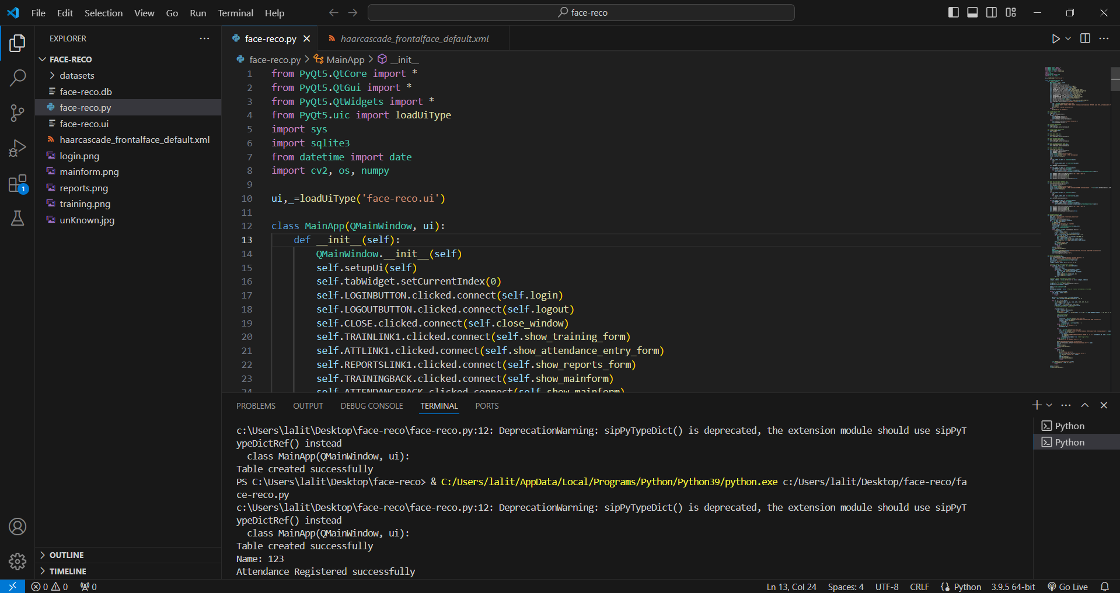

**Fig 9.1: Running Python File**

**Screenshot 2: Home Page**

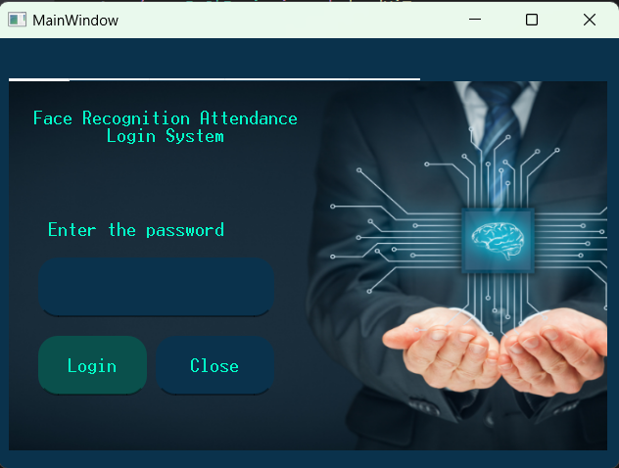

**Fig 9.2: Home Page**

**Screenshot 3: After Login Page**

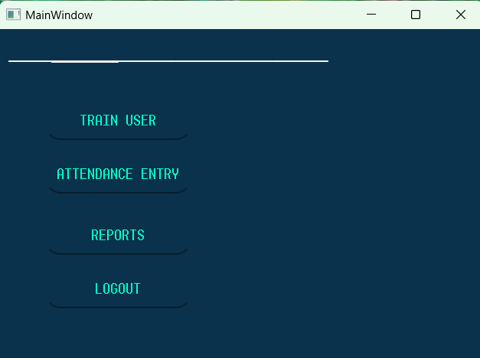

**Fig 9.3: After Login Page**

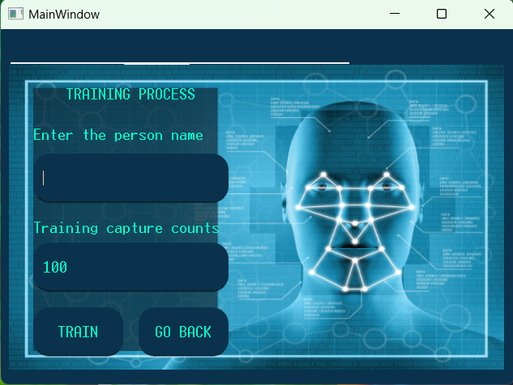**Screenshot 4: Training Page**

**Fig 9.4: Training Page**

**Screenshot 5: Record Attendance Page:**

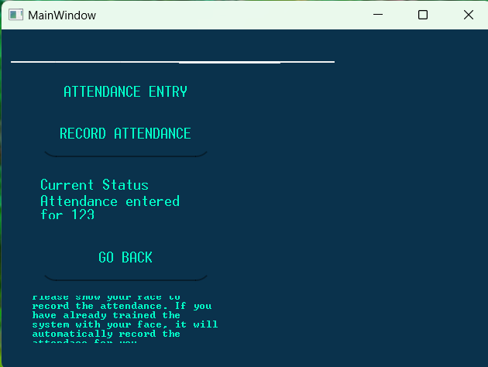

**Fig 9.5: Record Attendance Page**

**Screenshot 6: Attendance Report Page**

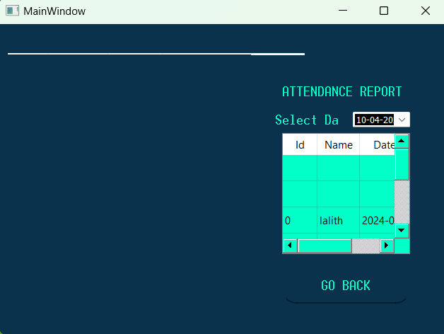

**Fig 9.6: Attendance Report Page**

**Screenshot 7: Recording the attendance through Webcam Page**

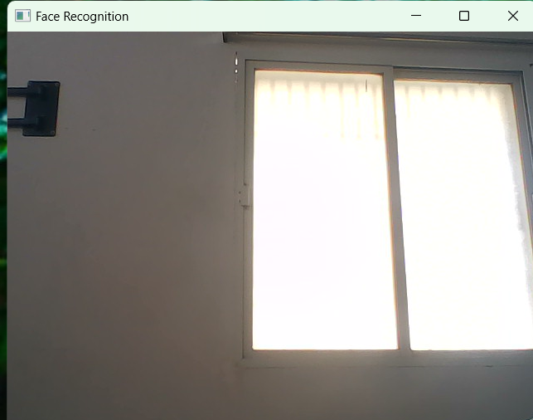

**Fig 9.7: Recording the attendance through Webcam Page**

**10.FUTURE ENHANCEMENT**

**FUTURE ENHANCEMENT**

The heart attack risk prediction system, while effective in its current form, has several promising avenues for future enhancement that can significantly improve its performance, scalability, and impact. One of the most impactful upgrades would be the integration of **real-time health monitoring devices** such as smartwatches, fitness trackers, or medical-grade IoT sensors. These devices can provide continuous data streams including heart rate, physical activity, sleep patterns, and even ECG readings, enabling the system to make dynamic and time-sensitive predictions. This would transform the static prediction model into a proactive monitoring tool capable of providing real-time alerts.

Another key enhancement lies in **expanding and diversifying the dataset**. Currently, the model relies on a limited number of features and historical data. Incorporating a more comprehensive dataset with larger sample sizes, diverse age groups, and varied demographics can help reduce bias and improve the system's accuracy across different population segments. Additionally, including more health indicators such as genetic factors, stress levels, medication history, and medical imaging could provide deeper insights and make the predictions more robust.

The system can also evolve by offering **personalized lifestyle recommendations** based on individual prediction results. For example, if a user is identified as high-risk, the system could suggest customized diet plans, exercise routines, and mental health activities aimed at reducing that risk.

Lastly, **multi-language support**, **mobile app deployment**, and **cloud-based scalability** can further increase accessibility and usability. With language localization, people from different regions can use the application in their native language. A mobile version would allow users to conveniently access the system anytime, and deploying it on cloud platforms like AWS or Azure would make it scalable for hospital systems and healthcare providers globally. These future enhancements aim to transform the application into a comprehensive, real-time, intelligent healthcare solution.

**11.CONCLUSION**

**CONCLUSION**

The heart attack risk prediction system successfully demonstrates how machine learning can be applied to healthcare to support early diagnosis and preventive treatment. By collecting essential patient health information and processing it through a well-optimized XGBoost model, the system provides accurate, real-time predictions about the likelihood of a heart attack. Supporting components such as SMOTE for class balancing and Optuna for hyperparameter tuning ensure that the model performs reliably across varied inputs. The integration of a user-friendly Flask web interface allows easy accessibility for users and healthcare providers alike.

This project highlights the potential of artificial intelligence to transform traditional healthcare practices by making them more data-driven, efficient, and personalized. While the current version offers strong predictive capabilities, future improvements such as real-time monitoring, mobile integration, and lifestyle recommendations can make the system even more impactful. Overall, the system not only aids in timely risk detection but also encourages awareness, helping users take proactive steps toward heart health and well-being.

.

**12.BIBLIOGRAPHY**

1. Paul Viola and Michael Jones, “Rapid Object Detection using a Boosted Cascade of Simple Features,” Proceedings of the IEEE Computer Society Conference on Computer Vision and Pattern Recognition (CVPR), 2001.

2. Buolamwini, Joy, and Timnit Gebru. “Gender Shades: Intersectional Accuracy Disparities in Commercial Gender Classification,” Proceedings of the 1st Conference on Fairness, Accountability and Transparency, 2018.

3. Chen, Tianqi, and Carlos Guestrin. “XGBoost: A Scalable Tree Boosting System,” Proceedings of the 22nd ACM SIGKDD International Conference on Knowledge Discovery and Data Mining, 2016.

4. Chawla, Nitesh V., et al. “SMOTE: Synthetic Minority Over-sampling Technique,” Journal of Artificial Intelligence Research, 2002.

5. Akiba, Takuya, et al. “Optuna: A Next-generation Hyperparameter Optimization Framework,” Proceedings of the 25th ACM SIGKDD International Conference on Knowledge Discovery & Data Mining, 2019.

6. Santhana Krishnan J., Dr. Geetha S., “Prediction of Heart Disease Using Machine Learning Algorithms,” 2019 1st International Conference on Innovations in Information and Communication Technology (ICIICT), IEEE.

7. https://ieeexplore.ieee.org/document/10803124

8. https://ieeexplore.ieee.org/document/10725867

9. https://www.nature.com/articles/s41598-024-74656-2

10. https://www.researchgate.net/publication/354221694_A_Machine_Learning_Approach_for_Heart_Attack_Prediction